**Cloud computing combined notes**

**Cloud computing meaning**

**Cloud computing** means that of all the computer hardware and software, it's provided for you as a service by another company and accessed over the Internet, in a completely seamless way.

**Simple e.g cloud computing**

* When you sit at your PC and type a query into Google
* Web-based email
* Preparing documents over the Net

**What makes cloud computing different?**

* **It's "on-demand :** Cloud services are available on-demand and often bought on a "pay-as-you go" or subscription basis.
* **It's managed:** the service you use is provided by someone else and managed on your behalf.
* **It's public or private**: It comes in two basic flavors, public and private, which are the cloud equivalents of the Internet and Intranets.

**Types of cloud computing**

**Infrastructure as a Service (IaaS)** - Means you're buying access to raw computing hardware over the Net, such as servers or storage.

**Software as a Service (SaaS)** - Means you use a complete application running on someone else's system. Web-based email.

**Platform as a Service (PaaS)** -means you develop applications using Web-based tools so they run on systems software and hardware provided by another company.

**Advantages of cloud computing**

* Lower upfront costs and reduced infrastructure costs.
* Easy to grow your applications.
* Scale up or down at short notice.
* Only pay for what you use.
* Everything managed under SLAs.
* Overall environmental benefit of many users efficiently sharing large systems.

**disadvantages of cloud computing**

* Greater dependency on service providers.
* Risk of being locked into proprietary
* Potential privacy and security risks of putting valuable data on someone else's system in an unknown location?
* Dependency on a reliable Internet connection.

**CLOUD HOSTING OR SERVER ON-DEMAND HOSTING, CLOUD SERVER HOSTING OR CLUSTER SERVER HOSTING**

* Hosting services that are provided to customers via multiple connected servers that comprise a cloud, as opposed to being provided by a single server or virtual server.
* While security and lack of full control of data are the most frequently cited concerns with cloud hosting, there are numerous benefits possible with cloud hosting, including increased reliability and accessibility, seamless scalability and cost efficiency

**Traditionally, web hosting came in two flavors:**

* **high-cost managed hosting**, in which you have your own private server dedicated to running only your website and its applications,
* **low-cost shared hosting**, where your site and apps run on a large server with a number of other sites run by other people.

**CLOUD SERVER SETUP**

**Rackspace's Cloud Servers, Liquid Web's Storm on Demand**, and **Amazon's Elastic Compute Cloud** (EC2) are three examples of this kind of cloud hosting

**How do cloud servers work**

* **Hosting products described as "cloud servers"** are generally virtual slices of large, physical servers running what's called virtualization software (the most common types being VMware® and Xen® hypervisor for Linux and Microsoft® Hyper-V™ for Windows).

**Cloud servers VS Shared Hosting**

* **virtual servers** are essentially independent of one another, so you're not at risk from other people's applications or websites.
* **You have full root access to your virtual server** (unlike on shared hosting, where different users' files are simply subdirectories of a single server running a single operating system) and your own unique IP address
* (so, unlike with shared hosting, **there is no risk to your site if other people host "dodgy**" websites on the same machine),
* and **you can reboot or reimage, as you wish**—you can even run entirely different operating systems on the same physical server.

**IS CLOUD COMPUTING *REALLY* BETTER FOR THE ENVIRONMENT**

* In theory, cloud computing is environmentally friendly because **it uses fewer resources** (servers, cooling systems, and all the rest) **and less energy**.
* A company that has embraced cloud systems can handle more customers on far fewer physical servers, with big savings in equipment, maintenance, and energy costs.

**KEY PROPERTIES OF CLOUD COMPUTING**

**User centric** : This means once a user is connected to cloud any data there, becomes his property and all the devices connected becomes his.

**Task Centric** : Cloud computing focus on what one need and how application can do it for us.

**Powerful**: there is large computers more computing power and mass data storage possible.

**Self-Healing:** because hot backups are available. Hence if one document crashes there will be its duplicate ready to run.

**Multi-tenancy & Intelligence**: Multi-tenancy refers to sharing of data and costs across a large pool of users. As various data are stored in cloud data mining and analysis are necessary for accessing information in an intelligent manner.

**Programmable**: Many processes in cloud computing shall be automated such as backing up crashed data with its duplicate. Hence programming is associated with cloud computing.

**Flexible**: Flexible as the users may be of different varieties and hence it has to match with their needs.

**ESSENTIAL CHARACTERISTICS OF CLOUD COMPUTING**

* **On-demand self-service:** A consumer can unilaterally provision computing capabilities automatically without requiring human interaction with each service provider.
* **Broad network access:** Capabilities are available over the network and accessed through standard mechanisms that promote use by heterogeneous thin or thick client platforms
* **Resource pooling:** The computing resources are pooled to serve multiple consumers using a multi-tenant model, with different physical and virtual resources dynamically assigned and reassigned according to consumer demand.
* **Rapid elasticity:** Capabilities can be elastically provisioned and released, in some cases automatically, to scale rapidly outward and inward commensurate with demand.
* **Measured service:** Cloud systems automatically control and optimize resource use by leveraging a metering capability at some level of abstraction appropriate to the type of service

**CLOUD COMPUTING SERVICE MODELS**

**Software as a Service (SaaS)**

A delivery model where the software and the associated data is hosted in a cloud environment by a third party the user accesses the software on demand using a browser on a computer or mobile device.

The agency does not buy the software.  Instead, the cloud service provider licenses the SaaS to the agency, which then enables multiple users to access the software.

**Platform as a Service (PaaS)**

is a delivery model where a CSP provides an online software development platform for an organization such as an agency.

The agency's developers use the CSP’s computing environments, tools, and libraries to create, test, manage, and host software applications.

**Infrastructure as a Service (IaaS)**

CSPs provide the necessary hardware and software upon which a customer can build a customized computing environment.

The CSP typically provides an unmanaged environment that enable the customer, to have any “guest” resources it needs installed:  operating systems, software bundles, storage capabilities, etc.

The customer retains full control of the computing environment and is responsible for configuring and maintaining the guest operating systems and associated applications and resources.

The CSP, however, is responsible for maintaining all of the physical equipment.

**LECTURE 2**

**DISTRIBUTED SYSTEMS**

* **A *distributed system*** is a collection of independent computers, interconnected via a network, capable of collaborating on a task.
* ***Distributed computing*** is computing performed in a distributed system.

**EXAMPLES OF DISTRIBUTED SYSTEMS**

* **Network of workstations (NOW):** a group of networked personal workstations connected to one or more server machines.
* **The Internet**
* **An intranet:** a network of computers and workstations within an organization, segregated from the Internet via a protective device (a firewall).

**COMPUTERS IN A DISTRIBUTED SYSTEM**

* **Workstations:** computers used by end-users to perform computing
* **Server machines:** computers which provide resources and services
* **Personal Assistance Devices:** handheld computers connected to the system via a wireless communication link.



**MONOLITHIC MAINFRAME APPLICATIONS VS. DISTRIBUTED APPLICATIONS**

* **The monolithic mainframe application architecture**:
  + Separate, single-function applications, such as order-entry or billing
  + Applications cannot share data or other resources
  + Developers must create multiple instances of the same functionality (service).
  + Proprietary (user) interfaces
* **The distributed application architecture**:
  + Integrated applications
  + Applications can share resources
  + A single instance of functionality (service) can be reused.
  + Common user interfaces
  + Autonomous Computers + Network
  + Communication via message-passing
  + No shared memory
  + No global clock
  + Range:
* **Why do we develop distributed systems?**
  + availability of powerful yet cheap microprocessors (PCs, workstations), continuing advances in communication technology,

**EXAMPLES OF DISTRIBUTED SYSTEMS**

* Local Area Network and Intranet
* Database Management System
* Automatic Teller Machine Network
* Internet/World-Wide Web
* Mobile and Ubiquitous Computing

**ADVANTAGES OF DISTRIBUTED SYSTEMS OVER CENTRALIZED SYSTEMS**

* **Economics**: a collection of microprocessors offer a better price/performance than mainframes. Low price/performance ratio: cost effective way to increase computing power.
* **Speed**: a distributed system may have more total computing power than a mainframe. Enhanced performance through load distributing.
* **Inherent distribution**: Some applications are inherently distributed. Ex. a supermarket chain.
* **Reliability**: If one machine crashes, the system as a whole can still survive. Higher availability and improved reliability.
* **Incremental growth**: Computing power can be added in small increments. Modular expandability
* **Another deriving force**: the existence of large number of personal computers, the need for people to collaborate and share information.

**ADVANTAGES OF DISTRIBUTED SYSTEMS OVER INDEPENDENT PCS**

* + Data sharing: allow many users to access to a common data base
  + Resource Sharing: expensive peripherals like color printers
  + Communication: enhance human-to-human communication, e.g., email, chat
  + Flexibility: spread the workload over the available machines

**DISADVANTAGES OF DISTRIBUTED SYSTEMS**

* + Software: difficult to develop software for distributed systems
  + Network: saturation, lossy transmissions
  + Security: easy access also applies to secrete data

**BASIC DESIGN ISSUES**

* General software engineering principles include rigor and formality, separation of concerns, modularity, abstraction, anticipation of change, …

**SPECIFIC ISSUES FOR DISTRIBUTED SYSTEMS:**

* + Naming
  + Communication
  + Software structure
  + System architecture
  + Workload allocation
  + Consistency maintenance

**NAMING**

* A name is resolved when translated into an interpretable form for resource/object reference.
  + Communication identifier (IP address + port number)
  + Name resolution involves several translation steps
* Design considerations
  + Choice of name space for each resource type
  + Name service to resolve resource names to comm. id.
* Name services include naming context resolution, hierarchical structure, resource protection

**COMMUNICATION**

* Separated components communicate with sending processes and receiving processes for *data transfer* and *synchronization.*
* **Message passing**: *send* and *receive* primitives
  + synchronous or blocking
  + asynchronous or non-blocking
  + Abstractions defined: channels, sockets, ports.
* Communication patterns: client-server communication (e.g., RPC, function shipping) and group multicast

**Synchronous Transmission**

* is used to describe a continuous and consistent timed transfer of data blocks.
* Synchronous data transmission is a data transfer method in which a continuous stream of data signals is accompanied by timing signals (generated by an electronic clock) to ensure that the transmitter and the receiver are in step (synchronized) with one another. The data is sent in blocks (called frames or packets) spaced by fixed time intervals.
* Synchronous transmission modes are used when large amounts of data must be transferred very quickly from one location to the other. The speed of the synchronous connection is attained by transferring data in large blocks instead of individual characters.

**Asynchronous Transmission**

* asynchronous transmission works in spurts and must insert a start bit before each data character and a stop bit at its termination to inform the receiver where it begins and ends.
* is used to describe the process where transmitted data is encoded with start and stop bits, specifying the beginning and end of each character.

**SOFTWARE STRUCTURE**

* Layers in centralized computer systems:

Applications

Middleware

Operating system

Computer and Network Hardware

* **Layers and dependencies in distributed systems:**

Applications

Distributed programming

support

Open services

Open system kernel services

Computer and network hardware

**SYSTEM ARCHITECTURES**

* Client-Server
* Peer-to-Peer
* Services provided by multiple servers
* Proxy servers and caches
* Mobile code and mobile agents
* Network computers
* Thin clients and mobile devices

**Clients Invoke Individual Servers**



**Peer-to-peer Systems**



**A Service by Multiple Servers**



**Web Proxy Server**



[**Proxy server**](https://www.upguard.com/glossary/proxy-server) **is an intermediary server that retrieves data from an Internet source, such as a webpage, on behalf of a user. They act as additional** [**data security**](https://www.upguard.com/blog/data-security) **boundaries protecting users from malicious activity on the internet.**

**Web Applets**



a very small application, especially a utility program performing one or a few simple functions

Computer server

**Thin Clients and Computer Servers**

network

Thin

Client

Network computer or PC

Application

Process

A *thin client* is a *computer* that runs from resources stored on a central server instead of a localized hard drive. *Thin clients* work by connecting remotely to a server-based computing environment where most applications, sensitive data, and memory, are stored.

**NETWORK OPERATING SYSTEMS**

* + loosely-coupled software on loosely-coupled hardware
  + A network of workstations connected by LAN
  + each machine has a high degree of autonomy
  + Files servers: client and server model
  + Clients mount directories on file servers
  + Best known network OS:
    - Sun’s NFS (network file servers) for shared file systems
  + a few system-wide requirements: format and meaning of all the messages exchanged

**(TRUE) DISTRIBUTED SYSTEMS**

* + tightly-coupled software on loosely-coupled hardware
  + provide a single-system image or a virtual uniprocessor
  + a single, global interprocess communication mechanism, process management, file system; the same system call interface everywhere
  + Ideal definition: A distributed system runs on a collection of computers that do not have shared memory, yet looks like a single computer to its users.”

**MULTIPROCESSOR OPERATING SYSTEMS**

* + Tightly-coupled software on tightly-coupled hardware
  + Examples: high-performance servers
  + shared memory
  + single run queue
  + traditional file system as on a single-processor system: central block cache

**COMMON CHARACTERISTICS**

* What are we trying to achieve when we construct a distributed system?
* Certain common characteristics can be used to assess distributed systems
  + Heterogeneity
  + Openness
  + Security
  + Scalability
  + Failure Handling
  + Concurrency
  + Transparency

**Heterogeneity**

* Variety and differences in
  + Networks
  + Computer hardware
  + Operating systems
  + Programming languages
  + Implementations by different developers
* **Middleware** as software layers to provide a programming abstraction as well as masking the heterogeneity of the underlying networks, hardware, OS, and programming languages (e.g., CORBA).
* **Mobile Code** to refer to code that can be sent from one computer to another and run at the destination (e.g., Java applets and Java *virtual machine*).

**Openness**

* Openness is concerned with extensions and improvements of distributed systems.
* Detailed interfaces of components need to be published.
* New components have to be integrated with existing components.
* Differences in data representation of interface types on different processors (of different vendors) have to be resolved.

**Security**

* In a distributed system, clients send requests to access data managed by servers, resources in the networks:
  + Doctors requesting records from hospitals
  + Users purchase products through electronic commerce
* Security is required for:
  + Concealing the contents of messages: security and privacy
  + Identifying a remote user or other agent correctly (authentication)
* New challenges:
  + Denial of service attack
  + Security of mobile code

**Scalability**

* Adaptation of distributed systems to
  + accommodate more users
  + respond faster (this is the hard one)
* Usually done by adding more and/or faster processors.
* Components should not need to be changed when scale of a system increases.
* Design components to be scalable!

**Failure Handling (Fault Tolerance)**

* Hardware, software and networks fail!
* Distributed systems must maintain *availability* even at low levels of hardware/software/network *reliability*.
* Fault tolerance is achieved by
  + Recovery
  + Redundancy

**Concurrency**

* Components in distributed systems are executed in concurrent processes.
* Components access and update shared resources (e.g. variables, databases, device drivers).
* Integrity of the system may be violated if concurrent updates are not coordinated.
  + Lost updates
  + Inconsistent analysis

**Transparency**

* Distributed systems should be perceived by users and application programmers as a whole rather than as a collection of cooperating components.
* Transparency has different aspects.
* These represent various properties that distributed systems should have.

**Access Transparency**

* Enables local and remote information objects to be accessed using identical operations.
* Example: File system operations in NFS.
* Example: Navigation in the Web.
* Example: SQL Queries

**Location Transparency**

* Enables information objects to be accessed without knowledge of their location.
* Example: File system operations in NFS
* Example: Pages in the Web
* Example: Tables in distributed databases

**Concurrency Transparency**

* Enables several processes to operate concurrently using shared information objects without interference between them.
* Example: NFS
* Example: Automatic teller machine network
* Example: Database management system

**Replication Transparency**

* Enables multiple instances of information objects to be used to increase reliability and performance without knowledge of the replicas by users or application programs
* Example: Distributed DBMS
* Example: Mirroring Web Pages.

**Failure Transparency**

* Enables the concealment of faults
* Allows users and applications to complete their tasks despite the failure of other components.
* Example: Database Management System

**Mobility Transparency**

* Allows the movement of information objects within a system without affecting the operations of users or application programs
* Example: NFS
* Example: Web Pages

**Performance Transparency**

* Allows the system to be reconfigured to improve performance as loads vary.
* Example: Distributed make.

**Scaling Transparency**

* Allows the system and applications to expand in scale without change to the system structure or the application algorithms.
* Example: World-Wide-Web
* Example: Distributed Database

**DESIGN ISSUES OF DISTRIBUTED SYSTEMS**

* Flexibility
* Reliability
* Performance

**Flexibility**

* Make it easier to change
* Monolithic Kernel: systems calls are trapped and executed by the kernel. All system calls are served by the kernel, e.g., UNIX.
* Microkernel: provides minimal services.
* 1) some memory management   
  2) some low-level process management and scheduling   
  3) low-level i/o  
  E.g., Mach can support multiple file systems, multiple system interfaces.

**Reliability**

* Distributed system should be more reliable than single system.
  + Availability: fraction of time the system is usable. Redundancy improves it.
  + Need to maintain consistency
  + Need to be secure
  + Fault tolerance: need to mask failures, recover from errors.

**Performance**

* Without gain on this, why bother with distributed systems.
* Performance loss due to communication delays:
  + fine-grain parallelism: high degree of interaction
  + coarse-grain parallelism
* Performance loss due to making the system fault tolerant.

**Communication Networks**

* Computers are connected through a communication network
  + **Wide Area Networks (WAN)**connect computers spread over a wide geographic area  
    point-to-point or store-and-forward -- data is transferred between computers through a series of switches  
    switch -- a special purpose computer responsible for routing data (to avoid network congestion)  
    data can be lost due to: switch crashes, communication link failures, limited buffers at switches, transmission errors, etc.
  + **Packet Switching versus Circuit Switching**
    - i) circuit switching -- a dedicated path between a source and a  
       destination e.g., telephone connection.  
       wastes bandwidth (bandwidth = amount of data transmitted   
       in a given time period)
    - ii) packet switching -- message or data is broken into packets  
       packets are routed independently  
       better network utilization  
       disassemble and assembler overheads  
       The ISO OSI Reference Model

**Local Area Networks (LAN)**

**Lecture 3**

**Deployment Models in Cloud Computing**

* Cloud services can be deployed in different ways, depending on the organizational structure and the provisioning location.
* **Four deployment models are usually distinguished:**
* public
* private
* community and
* hybrid cloud service usage.

**Public Cloud**

* The deployment of a public cloud computing system is characterized on the one hand by the public availability of the cloud service offering and on the other hand by the public network that is used to communicate with the cloud service.
* The cloud services and cloud resources are procured from very large resource pools that are shared by all end users.
* These IT factories provision the resources precisely according to required quantities.
* By optimizing operation, support, and maintenance, the cloud provider can achieve signiﬁcant economies of scale, leading to low prices for cloud resources.
* In addition, public cloud portfolios employ techniques for resource optimization; however, these are transparent for end users and represent a potential threat to the security of the system
* If a cloud provider runs several datacenters, for instance, resources can be assigned in such a way that the load is uniformly distributed between all centers.

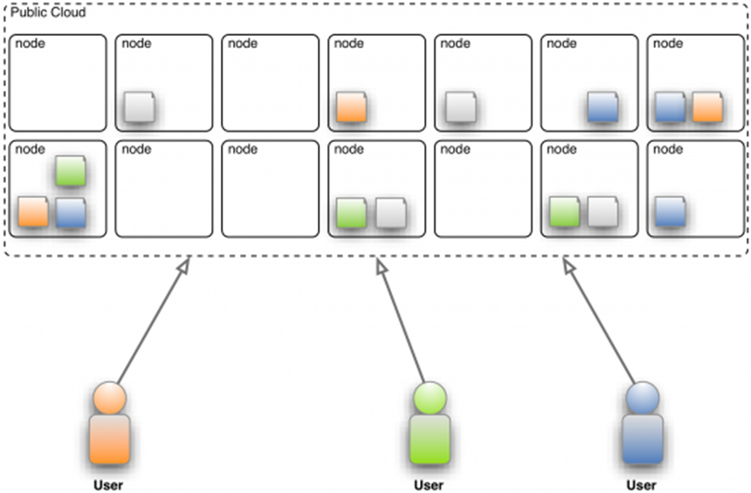

: Three users accessing a public cloud

* Some of the best-known examples of public cloud systems are Amazon Web Services (AWS) containing the Elastic Compute Cloud (EC2) and the Simple Storage Service (S3) which form an IaaS cloud offering and the Google App Engine with provides a PaaS to its customers.
* The customer relationship management (CRM) solution Salesforce.com is the best-known example in the area of SaaS cloud offerings

**Private Cloud**

* Private cloud computing systems emulate public cloud service offerings within an organization’s boundaries to make services accessible for one designated organization.
* Private cloud computing systems make use of virtualization solutions and focus on consolidating distributed IT services often within data centers belonging to the company.
* The chief advantage of these systems is that the enterprise retains full control over corporate data, security guidelines, and system performance. In contrast, private cloud offerings are usually not as large-scale as public cloud offerings resulting in worse economies of scale.

A u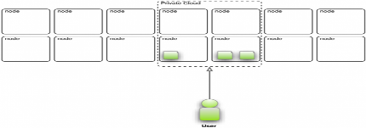 user accessing a private cloud

**Community Cloud**

* In a community cloud, organizations with similar requirements share a cloud infrastructure. It may be understood as a generalization of a private cloud, a private cloud being an infrastructure which is only accessible by one certain organization.

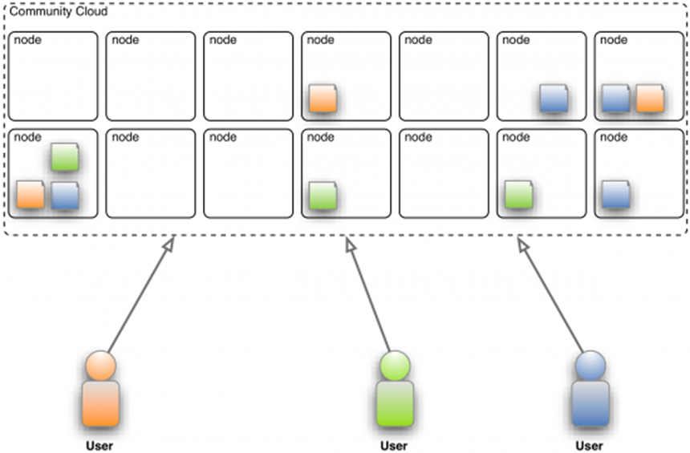

Three users accessing a community cloud

**Hybrid Cloud**

* A hybrid cloud service deployment model implements the required processes by combining the cloud services of different cloud computing systems, e.g. private and public cloud services. The hybrid model is also suitable for enterprises in which the transition to full outsourcing has already been completed, for instance, to combine community cloud services with public cloud services.

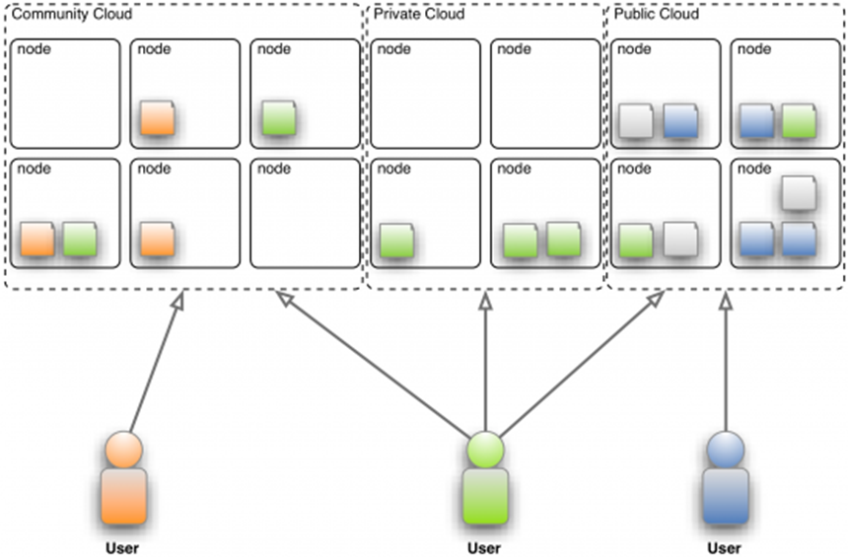

Hybrid cloud usage

**Cloud Computing Stack**

* Cloud Computing is often described as a stack, as a response to the broad range of services built on top of one another under the moniker “Cloud”.
* The diagram in the next slide depicts the Cloud Computing stack – it shows three distinct categories within Cloud Computing: Software as a Service, Platform as a Service and Infrastructure as a Service.

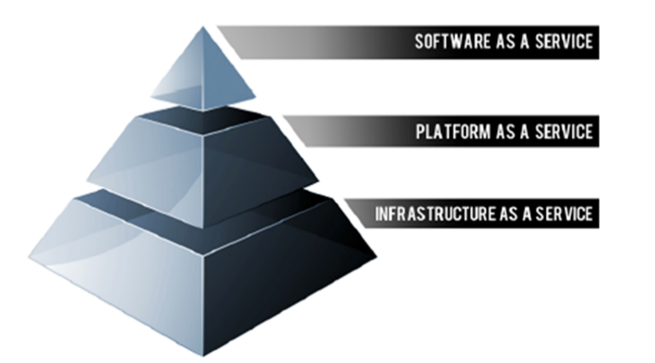

* The diagram below depicts the Cloud Computing stack – it shows three distinct categories within Cloud Computing: Software as a Service, Platform as a Service and Infrastructure as a Service.

**(Software as a Service)**

* software that is deployed over the internet... With SaaS, a provider licenses an application to customers either as a service on demand, through a subscription, in a “pay-as-you-go” model, or (increasingly) at no charge when there is opportunity to generate revenue from streams other than the user, such as from advertisement or user list sales

***Characteristics of SaaS***

• Web access to commercial software   
• Software is managed from a central location   
• Software delivered in a “one to many” model   
• Users not required to handle software upgrades and patches   
• Application Programming Interfaces (APIs) allow for integration between different pieces of software

***Where SaaS Makes Sense***

• “Vanilla” offerings where the solution is largely undifferentiated. A good example of a vanilla offering would include email where many times competitors use the same software precisely because this fundamental technology is a requirement for doing business, but does not itself confer a competitive advantage  
• Applications where there is significant interplay between the organization and the outside world. For example, email newsletter campaign software

• Applications that have a significant need for web or   
 mobile access. An example would be mobile sales   
 management software   
• Software that is only to be used for a short-term need.   
 An example would be collaboration software for a   
 specific project   
• Software where demand spikes significantly, for   
 example tax or billing software used once a month

**Where SaaS May Not be the Best Option**

• Applications where extremely fast processing of real time data is required   
• Applications where legislation or other regulation does not permit data being hosted externally   
• Applications where an existing on-premise solution fulfills all of the organization’s needs

**(Platform as a Service)**

***Characteristics of PaaS***

• Services to develop, test, deploy, host and maintain applications in the same integrated development environment. All the varying services needed to fulfil the application development process   
• Web based user interface creation tools help to create, modify, test and deploy different UI scenarios   
• Multi-tenant architecture where multiple concurrent users utilize the same development application   
• Built in scalability of deployed software including load balancing and failover

• Integration with web services and databases via   
 common standards   
• Support for development team collaboration – some   
 PaaS solutions include project planning and   
 communication tools   
• Tools to handle billing and subscription management

***Where PaaS Makes Sense***

* In any situation where multiple developers will be working on a development project or where other external parties need to interact with the development process. As the case study illustrates, it is proving invaluable for those who have an existing data source – for example sales information from a customer relationship management tool, and want to create applications which leverage that data.
* Finally, PaaS is useful where developers wish to automate testing and deployment services.
* Examples include Google App Engine, Microsoft Azure Services, and the Force.com platform.

***Where PaaS May Not be the Best Option***

• Where the application needs to be highly portable in   
 terms of where it is hosted   
• Where proprietary languages or approaches would   
 impact on the development process   
• Where a proprietary language would hinder later   
 moves to another provider – concerns are raised   
 about vendor lock-in  
• Where application performance requires   
 customization of the underlying hardware and   
 software

**(Infrastructure as a Service)**

* Infrastructure as a Service (IaaS) is a way of delivering Cloud Computing infrastructure – servers, storage, network and operating systems – as an on-demand service. Rather than purchasing servers, software, datacenter space or network equipment, clients instead buy those resources as a fully outsourced service on demand

***Characteristics of IaaS***

•Resources are distributed as a service   
• Allows for dynamic scaling   
• Has a variable cost, utility pricing model   
• Generally includes multiple users on a single piece of   
 hardware

***Where IaaS Makes Sense***

• Where demand is very volatile – any time there are significant spikes and troughs in terms of demand on the infrastructure   
• For new organizations without the capital to invest in hardware   
• Where the organization is growing rapidly and scaling hardware would be problematic   
• Where there is pressure on the organization to limit capital expenditure and to move to operating expenditure   
• For specific line of business, trial or temporary infrastructural needs

***Where IaaS May Not be the Best Option***

• Where regulatory compliance makes the offshoring   
 or outsourcing of data storage and processing   
 difficult   
• Where the highest levels of performance are   
 required, and on-premise or dedicated hosted   
 infrastructure has the capacity to meet the   
 organization’s needs

**Lecture 4**

**Cloud Computing Architecture – Components & SaaS, PaaS, IaaS**

***Cloud Computing architecture*** basically comprises of the two parts. They are the **front-end** and the **back-end**. The **front end** is the end which uses by the user and the **back-end** manages by the host. Both the end connects to each other with the means of internet.

[***Do you know How Cloud Computing Works?***](https://data-flair.training/blogs/how-cloud-computing-works/)

**i. Front End**

The front end is the client part of Cloud Computing which uses as per the requirement of the user. Front-end comprises of the applications and the interfaces which help to access the cloud computing. Example- Browser or an app created by the company itself.

**ii. Back End**

The back end is a part which manages by the allotted authorities of the company and their back end has large data storage facilities, Virtual machines, security system, and servers. They are also engaged in traffic management along with security management.

**Components of Cloud Computing Architecture**

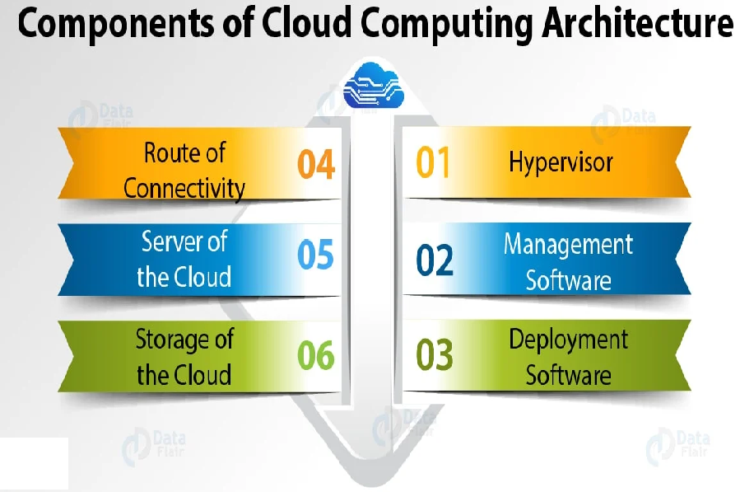

**i. Hypervisor**

The hypervisor is also known as *Virtual Machine Monitor*. This consists of the software, hardware, and firmware which makes and runs the virtual machines. The Hypervisor provides a user with a platform which is known as *Virtual Operating Platform*.

This allows us to manage the guest’s operating system to use the cloud. This can be also known as the traditional term of the kernel in an operating system.

**ii. Management Software**

Management software consists of various plans and the strategies which help to increase the performance of the cloud. This management software provides many features such as on-time delivery of storage, proper security, all-time access, and many other facilities.

This is one of the important parts of Cloud Computing architecture. One of the important features of this is the compliance auditing, management of overseeing disaster, and contingency plans.

**iii. Deployment Software**

Cloud deployment simply means *to initiate the working of the SaaS, PaaS, and IaaS*. This initiates the solutions that can access by the users or the customers.

This deployment consists of all the mandatory installations and configurations of the cloud. This emerges from the back end and implements before the provisioning occurs.

**iv. Route of Connectivity**

It is an important part of the Cloud Computing architecture, through which the whole cloud gets connected. The speed of transfer depends on the network which is the internet connection.

There are many cloud servers present which connects with the help of this virtual route. This also provides a facility to the user by allowing them to customize the route and protocol.

**v. A server of the Cloud**

A cloud server is a virtual server running in cloud computing premises. It’s engineered, hosted and delivered via a cloud computing platform via the web. It can be accessed from anywhere.

Cloud servers are stable, quick and secured. They avoid the hardware problems seen with physical servers, and that they are seemingly to be the foremost stable choice for businesses. Also, call as virtual servers.

Cloud servers have all the software they need to run and can operate as non-dependent units. It also has the profit because it is incredibly simple and fast to upgrade by adding memory and disk space, further as being more cost-effective.

**vi. Storage of the Cloud**

Cloud storage service, construct to produce applications, services and organizations with access to offsite storage capability that may provision instantly are versatile in scaling automatically at runtime and is globally accessible.

An Infrastructure as a Service (IaaS) service model delivers scalable, flexible and redundant storage capability through net services API, online interfaces and thin client applications.

Cloud Storage also benefits the user by providing remote access with the help of internet. The storage services are very quick to access. Cloud information is often held on, altered and retrieved from a remote cloud storage server over the web below a utility computing model.

**Cloud-Based Delivery**

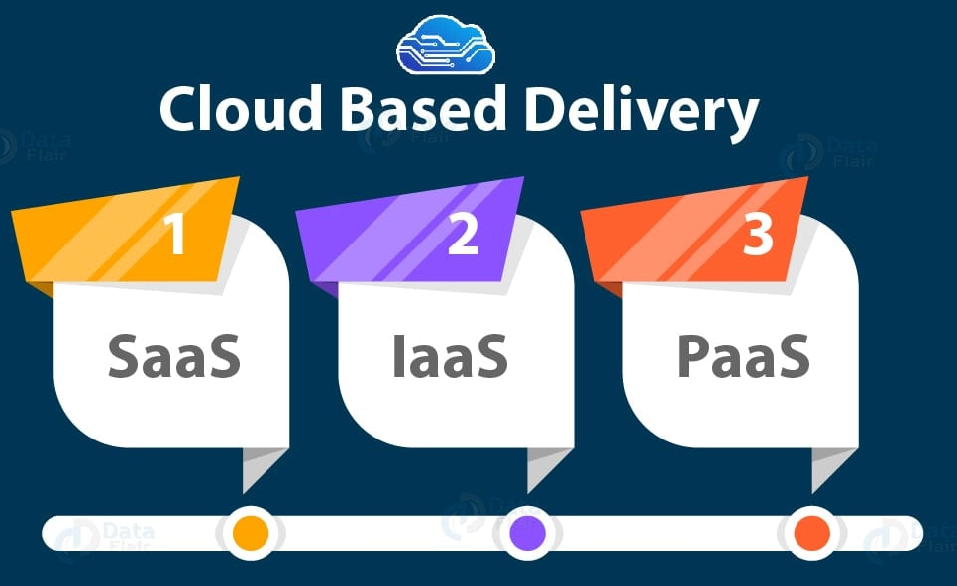

**i. SaaS**

SaaS stands for **Software as a service** where the cloud provider provides software with the help of internet.

It is scalable and provides a benefit that the system administrators can upload the applications to each of their own servers. The customers using SaaS can also access the application without installing the software.

**Key features of SaaS are:**

* Never having to manage with installing or upgrading software
* Equipment failure does not result in data loss
* Scalable use of resources adapted on business needs

SaaS is suited for non-technical companies and startups who wish to deploy their websites and applications rapidly. Popular SaaS solutions are email and collaboration and customer relationship management.

**Popular SaaS examples:**

* Google G Suite
* Microsoft Office 365
* Mailchimp

**ii. IaaS**

IaaS stands for **Infrastructure as a service**. This means that taking the physical hardware and providing the virtual services. In this, there are businesses which pay the fee to run virtual servers, network, and storage from the cloud. This infrastructure maintains by the back end.

**Key features of IaaS are:**

* Scalable infrastructure that accommodates business and operational needs
* Overview and full control over the infrastructure
* IaaS is on-demand and can be purchased instead of hardware

These solutions are suited to companies with a highly skilled set of developers who can work to build applications and digital experiences from scratch themselves. If the technical team can also manage traffic loads and server maintenance in a scalable way, then IaaS can offer a full overview and control over the infrastructure.

**Some popular IaaS examples are:**

* Amazon Web Services EC2
* Microsoft Azure IaaS / Virtual Machines

Google Cloud Compute Engine

**iii. Paas**

PaaS stands for **Platform as a service** in this the third-party provider delivers hardware and software tools. This basically benefits those who are need of application development.

The host providing this service provides the hardware and software on its own. This benefits the user by not installing the software at their premises.

Briefly put, PaaS is a combination between both the infrastructure and the software needed for software applications. Benefits of PaaS are reducing the amount of coding necessary, automating policies and migrating applications to a hybrid model.

**Key features of PaaS are:**

* Tools for application development and hosting in the same environment
* The provider manages security, operating system, server software backups
* Reduces the amount of coding and automates business policies

PaaS makes an optimal solution to a team of developers that want the flexibility to build applications from scratch but want to avoid the underlying tasks like runtime and traffic load management. This type of architecture provides developers with a self-service portal for managing infrastructure from centralized IT operations but also the platforms that are installed on top of the hardware. The PaaS can be delivered through a hybrid model that uses both public IaaS and on-premise infrastructure or as a pure private PaaS.

**Popular PaaS examples are:**

* Google App Engine
* Heroku
* Out Systems
* **SaaS vs PaaS vs IaaS: which one is right for you?**

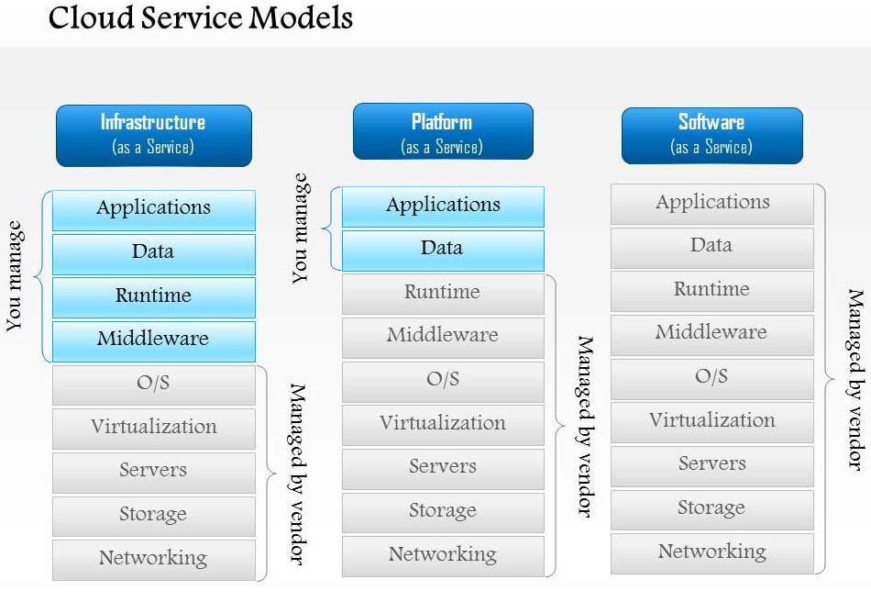

**Lecture 5**

**Virtualization**

**How Virtualization meets cloud properties?**

**Properties and Characteristics**

* As a cloud provider, all of the fundamental the following properties and characteristics should be of concern and implemented.

**Scalability & Elasticity**

* **What do scalability and elasticity mean in IaaS?**
  + Clients should be able to dynamically increase or decrease the amount of infrastructure resources in need.
  + Large amount of resources provisioning and deployment should be done in a short period of time, such as several hours or days.
  + System behavior should remain identical in small scale or large one.
* **How to approach scalability and elasticity in IaaS?**
  + For computation resources:
    - Dynamically create/terminate VMs for clients on demand.
    - Integrate hypervisors among all physical machines to collaboratively control and manage all virtual machines.
  + For storage resources:
    - Dynamically allocate or de-allocate virtual storage space for clients.
    - Integrate all physical storage resources in the entire IaaS system
    - Offer initial storage resources by thin provisioning technique.
  + For communication resources:
    - Dynamically connect or disconnect the linking state of virtual networks for clients on demand.
    - Dynamically divide the network request flow to different physical routers to maintain access bandwidth.

**Availability & Reliability**

* **What do availability and reliability mean in IaaS?**
  + Clients should be able to access computation resources without considering the possibility of hardware failure.
  + Data stored in IaaS cloud should be able to be retrieved when needed without considering any natural disaster damage.
  + Communication capability and capacity should be maintained without considering any physical equipment shortage.
* **How to approach availability and reliability in IaaS?**
  + For computation resources:
    - Monitor each physical and virtual machine for any possible failure.
    - Regularly backup virtual machine system state for disaster recovery.
    - Migrate virtual machine among physical machines for potential failure prevention.
  + For storage resources:
    - Maintain data pieces replication among different physical storage devices.
    - Regularly backup virtual storage data to geographical remote locations for disaster prevention.
  + For communication resources:
    - Built redundant connection system to improve robustness.

**Manageability & Interoperability**

* **What do manageability and interoperability mean in IaaS?**
  + Clients should be able to fully control the virtualized infrastructure resources which allocated to them.
  + Virtualized resources can be allocated by means of system control automation process with pre-configured policy.
  + States of all virtualized resource should be fully under monitoring.
  + Usage of infrastructure resources will be recorded and then billing system will convert this information to user payment.
* **Manageability and interoperability in IaaS?**
  + For computation resources:
    - Provide basic virtual machine operations, such as creation, termination, suspension, resumption and system snapshot.
    - Monitor and record CPU and memory loading for each VM.
  + For storage resources:
    - Monitor and record storage space usage and read/write data access from user for each virtual storage resource.
    - Automatic allocate/de-allocate physical storage according to space utilization.
  + For communication resources:
    - Monitor and record the network bandwidth consumption for each virtual link.
    - Automatically reroute the data path when computation and storage are duplicated.

**Performance & Optimization**

* **What do performance and optimization mean in IaaS?**
  + Physical resources should be highly utilized among different clients.
  + Physical resources should form a large resource pool which provide high computing power through parallel processing.
  + Virtual infrastructure resources will be dynamically configured to an optimized deployment among physical resources.
* **How to approach performance and optimization in IaaS?**
  + For computation resources:
    - Deploy virtual machine with load balancing consideration.
    - Live migrate virtual machines among physical ones to balance the system loading.
  + For storage resources:
    - Deploy virtual storage with hot spot access consideration.
    - Live migrate virtual storage among physical ones with different performance level.
  + For communication resources:
    - Consider network bandwidth loading when deploying virtual machines and storage.
    - Dynamically migrate virtual machines or storage to balance network flow.

**Accessibility & Portability**

* **What do accessibility and portability mean in IaaS?**
  + Clients should be able to control, manage and access infrastructure resources in an easy way, such as the web-browser, without additional local software or hardware installation.
  + Provided infrastructure resources should be able to be reallocated or duplicated easily.
* **How to approach accessibility and portability in IaaS?**
  + For computation resources:
    - Cloud provider integrates virtual machine management and access through web-based portal.
    - Comply the virtual machine standard for portability.
  + For storage resources:
    - Cloud provider integrates virtual storage management and access through web-based portal.
  + For communication resources:
    - Cloud provider integrates virtual network management and access through web-based portal.

**Cloud Computing and Virtualization**

* Virtualization enables a single computer to host multiple independent virtual computers called virtual machines (VM) that share the host computer hardware.
* Virtualization software separates the actual physical hardware from the VM instances.
* An image of a VM can be saved as a file and then be re-started when required.
* Cloud computing separates the applications from the hardware.
* Service providers such as Amazon Web Services (AWS) own and manage the cloud infrastructure.
* Virtualization is the foundation which supports cloud computing.

**Traditional Server Deployment**

* Traditionally, organizations delivered applications and services using powerful dedicated servers.
* These dedicated servers are equipped with large amounts of RAM, powerful CPUs, and multiple large storage devices.
* Disadvantages include: wasted resources, single-point of failure, and server sprawl.

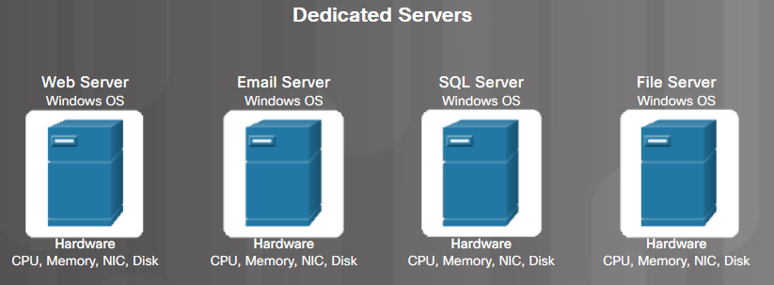

**Server Virtualization**

* **Server virtualization takes advantage of idle resources to reduce the number of servers required.**
* **A program called the hypervisor is used to manage the computer resources and various VMs.**
* **It provides VMs access to the hardware in the physical machine such as CPUs, memory, disk controllers, and NICs.**
* **Each VM runs a complete and separate operating system.**

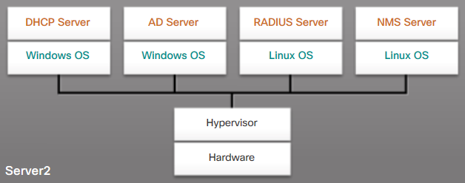

**Advantages of Server Virtualization**

* Better use of resources
* Less space required
* Less energy consumed
* Reduced cost
* Faster server provisioning
* Maximize server uptime
* Improved disaster recovery
* Support for legacy systems

**Client-Side Virtualization**

* Client-side virtualization enables users to run VMs on their local computer.
* It allows users to test new operating systems, software, or to run older software.
* Host computer – the physical computer controlled by a user.
* Host OS - the operating system of the host computer.
* Guest OS - the operating system that is running in the VM.

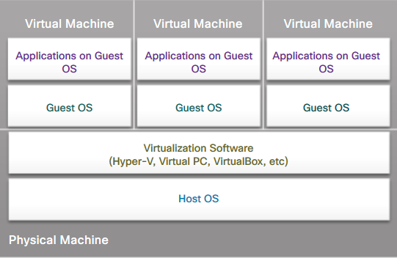

**What is virtualization?**

Virtualization is the creation of a virtual (rather than physical) version of something, such as an operating system, a server, a storage device or network resources.

It hides the physical characteristics of a resource from users, instead showing another abstract resource.

**But, where does virtualization come from?**

Virtualization concept comes from the component abstraction of system design, and it has been adapted in many systems levels.

**System abstraction:**

Computer systems are built on levels of abstraction.

Higher level of abstraction hides details at lower levels.

Designer of each abstraction level make use of the functions supported from its lower level, and provide another abstraction to its higher one.

**Example**

files are an abstraction of a disk

**an abstraction** is a representation that hides specifics from a consumer of services (a consumer being a computer program or human), making a system more generic and thus easily understood.

**A good example is your laptop’s operating system (OS).** It abstracts away all the details of how your computer works. You don’t need to know anything about CPU, memory, and how programs are handled, you just operate the OS and the OS deals with the details. All these details are hidden behind the OS “curtain” or abstraction.

Systems typically have multiple abstraction layers. This significantly simplifies development. When programming, developers build components compatible with a particular abstraction layer and don’t have to worry about all underlying specifics that can be very heterogeneous. If it works with the abstraction layer, it works with the system

**Machine level abstraction:**

For OS developers, a machine is defined by ISA (Instruction Set Architecture).

This is the major division between hardware and software.

**Examples:**

X86 (x86 is a family of complex instruction set computer (CISC) instruction set architectures initially developed by Intel based on the Intel 8086 microprocessor ...

MIPS (Microprocessor without Interlocked Pipelined Stages)

**OS level abstraction:**

For compiler or library developers, a machine is defined by ABI (Application Binary Interface).

This define the basic OS interface which may be used by libraries or user.

**Examples:**

User ISA

OS system call

**Library level abstraction:**

For application developers, a machine is defined by API (Application Programming Interface).

This abstraction provides the well-rounded functionalities.

**Examples:**

User ISA

Standard C library

Graphical library

**Virtualization** is the ability to run multiple operating systems on a single physical system and share the underlying hardware resources*

It is the process by which one computer hosts the appearance of many computers.

Virtualization is used to improve IT throughput and costs by using physical resources as a pool from which virtual resources can be allocated.

**Virtualization Architecture**

A Virtual machine (VM) is an isolated runtime environment (guest OS and applications)

Multiple virtual systems (VMs) can run on a single physical system

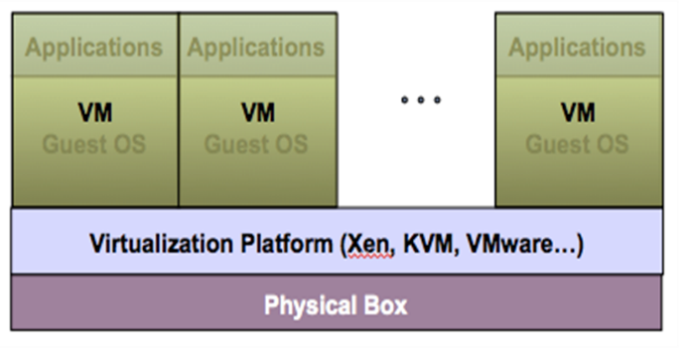

**Virtual Machine Monitor (Hypervisor)**

**What’s Virtual Machine Monitor (VMM)?**

VMM or Hypervisor is the software layer providing the virtualization.

**System architecture:  
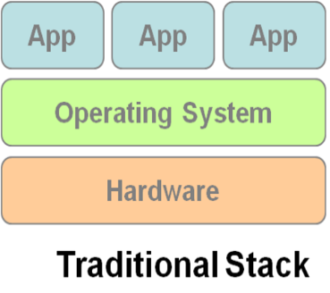 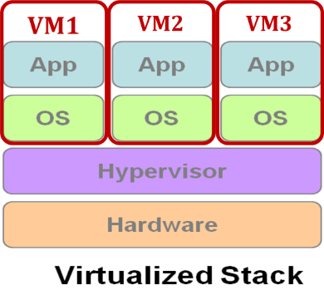**

**Virtualization Approaches**

**Full-Virtualization**

VMM simulates enough hardware to allow an unmodified guest OS.

**Para-Virtualization**

VMM does not necessarily simulate hardware, but instead offers a special API that can only be used by the modified guest OS.

**Full-Virtualization**

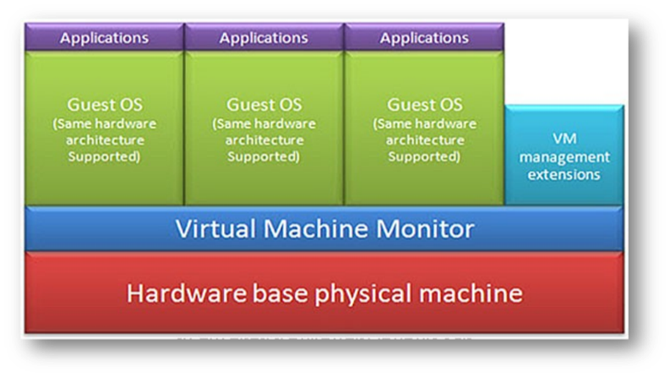

|  |  |
| --- | --- |
| ***Pros*** | **Need not to modify guest OS** |
| ***Cons*** | **Significant performance hit** |

**Para-Virtualization**

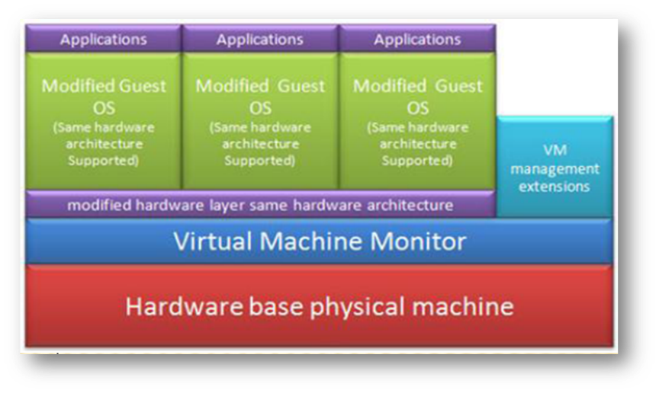

|  |  |
| --- | --- |
| ***Pros*** | **Light weight and high performance** |
| ***Cons*** | **Require modification of guest OS** |
|  |  |

**Benefits of Virtualization**

**Sharing** of resources helps cost reduction

**Isolation:** Virtual machines are isolated from each other as if they are physically separated

**Encapsulation:** Virtual machines encapsulate a complete computing environment

**Hardware Independence:** Virtual machines run independently of underlying hardware

**Portability:** Virtual machines can be migrated between different hosts.

**Virtualization in Cloud Computing**

**Cloud computing takes virtualization one step further:**

You don’t need to own the hardware

Resources are rented as needed from a cloud

Various providers allow creating virtual servers:

Choose the OS and software each instance will have

The chosen OS will run on a large server farm

Can instantiate more virtual servers or shut down existing ones within minutes

You get billed only for what you used

**Virtual Machine**

**What is Virtual Machine (VM)?**

VM is a software implementation of a machine (i.e. a computer) that executes programs like a real machine.

**Terminology:**

**Host (Target)**

The primary environment where  
will be the target of virtualization.

**Guest (Source)**

The virtualized environment where  
will be the source of virtualization

**isomorphism** is a structure-preserving mapping between two structures of the same type that can be reversed by an inverse mapping.

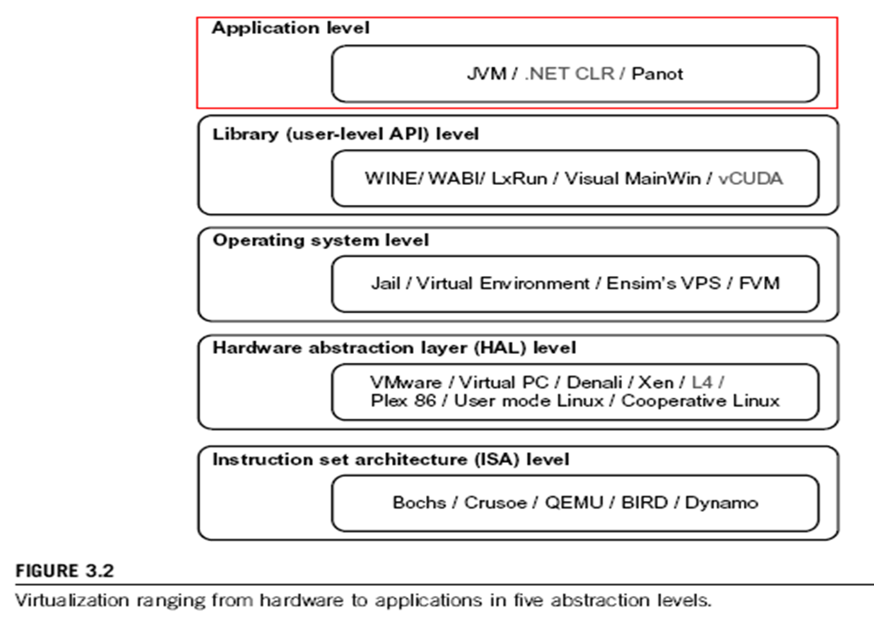

**Virtualization at ISA level:**

Emulating a given ISA by the ISA of the host machine. For example, MIPS binary code can run on an x-86-based host machine with the help of ISA emulation. Typical systems: Bochs, Crusoe, Quemu, BIRD, Dynamo

**Advantage:** It can run a large amount of legacy binary codes written for various processors on any given new hardware host machines; best application flexibility

**Shortcoming & limitation:** One source instruction may require tens or hundreds of native target instructions to perform its function, which is relatively slow. V-ISA requires adding a processor-specific software translation layer in the complier.

* This technology is usually included in the Hardware-Abstraction-Level-Virtualization

**Virtualization at Operating System level:**

It is an abstraction layer between traditional OS and user placations. This virtualization creates isolated containers on a single physical server and the OS-instance to utilize the hardware and software in datacenters. Typical systems: Jail / Virtual Environment / Ensim's VPS / FVM

**Advantage:** have minimal startup/shutdown cost, low resource requirement, and high scalability; synchronize VM and host state changes.

**Shortcoming & limitation:** all VMs at the operating system level must have the same kind of guest OS; poor application flexibility and isolation.

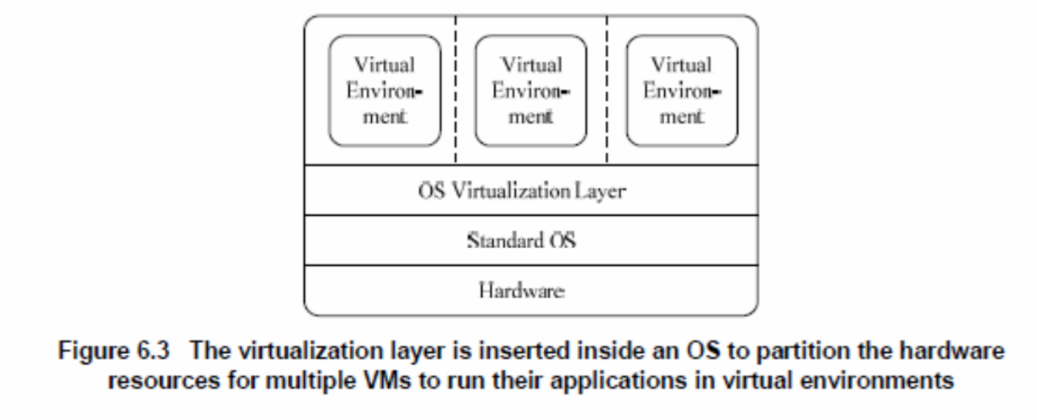

**Library Support level:**

It creates execution environments for running alien programs on a platform rather than creating VM to run the entire operating system. It is done by API call interception and remapping. Typical systems: Wine, WAB, LxRun, VisualMainWin

**Advantage:** It has very low implementation effort

**Shortcoming & limitation:** poor application flexibility and isolation

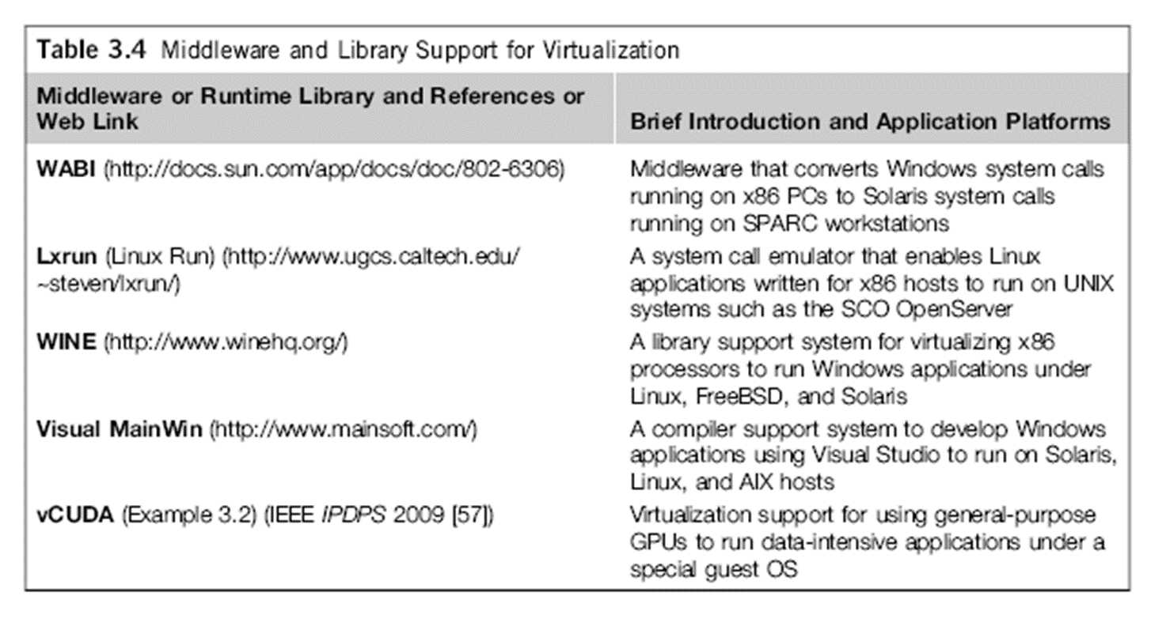

**Example: Visual MainWin (MainSoft)**

Mainsoft compiles the .NET source to Java bytecode without changing it, this allows the same .NET developers to maintain their application, using Visual Studio, even when it runs on the Java EE platform.

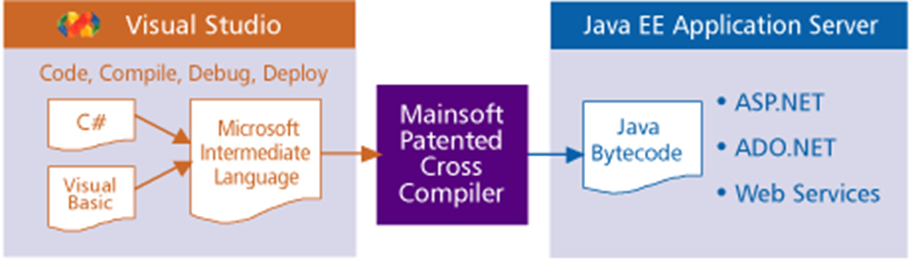

**Virtualization at User-Application level:**

It virtualizes an application as a virtual machine. This layer sits as an application program on top of an operating system and exports an abstraction of a VM that can run programs written and compiled to a particular abstract machine definition. Typical systems:   
JVM, NET CLI, Panot

**Advantage:** has the best application isolation

**Shortcoming & limitation:** low performance, low application flexibility and high implementation complexity.

**Server Virtualization –Hardware Abstraction Layer**

Low-Level VMM Operations (1)

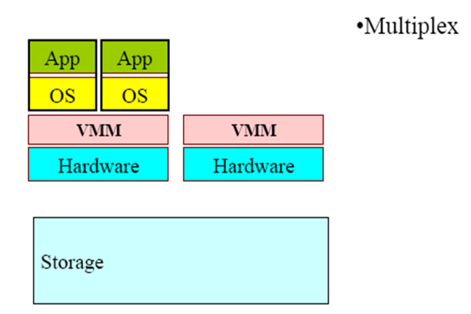

Low-Level VMM Operations (2)

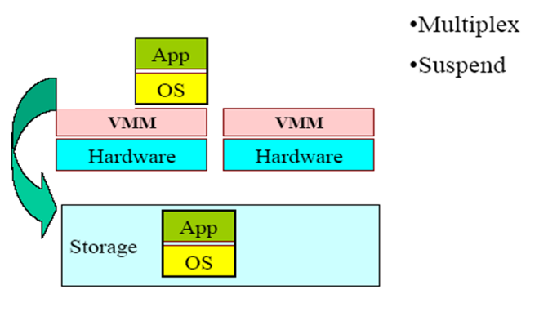

Low-Level VMM Operations (3)

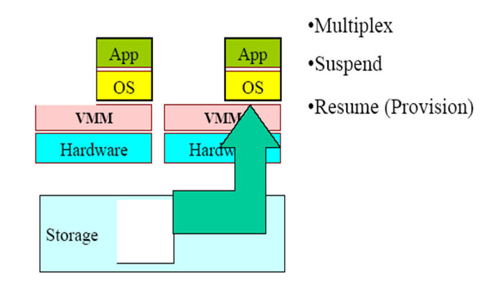

Low-Level VMM Operations (4)

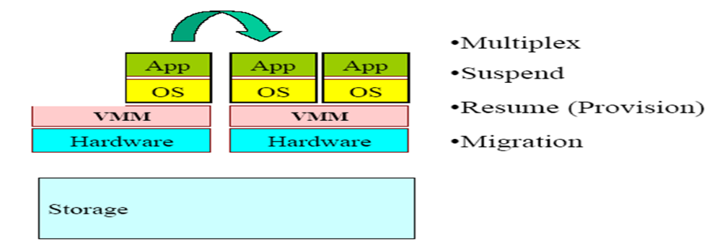

**Emulation vs. Virtualization**

**Emulation technique**

Simulate an independent environment where guest ISA and  
host ISA are different.

**Example**

Emulate x86 architecture on ARM platform.

**Virtualization technique**

Simulate an independent environment where guest ISA and  
host ISA are the same.

**Example**

Virtualize x86 architecture to multiple instances.

**System Virtual Machine**

Provide the entire operating system on same or different host ISA

Constructed at ISA level

Persistent

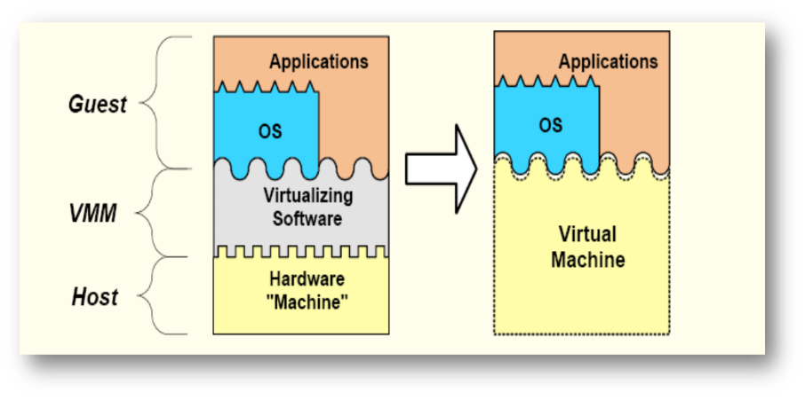

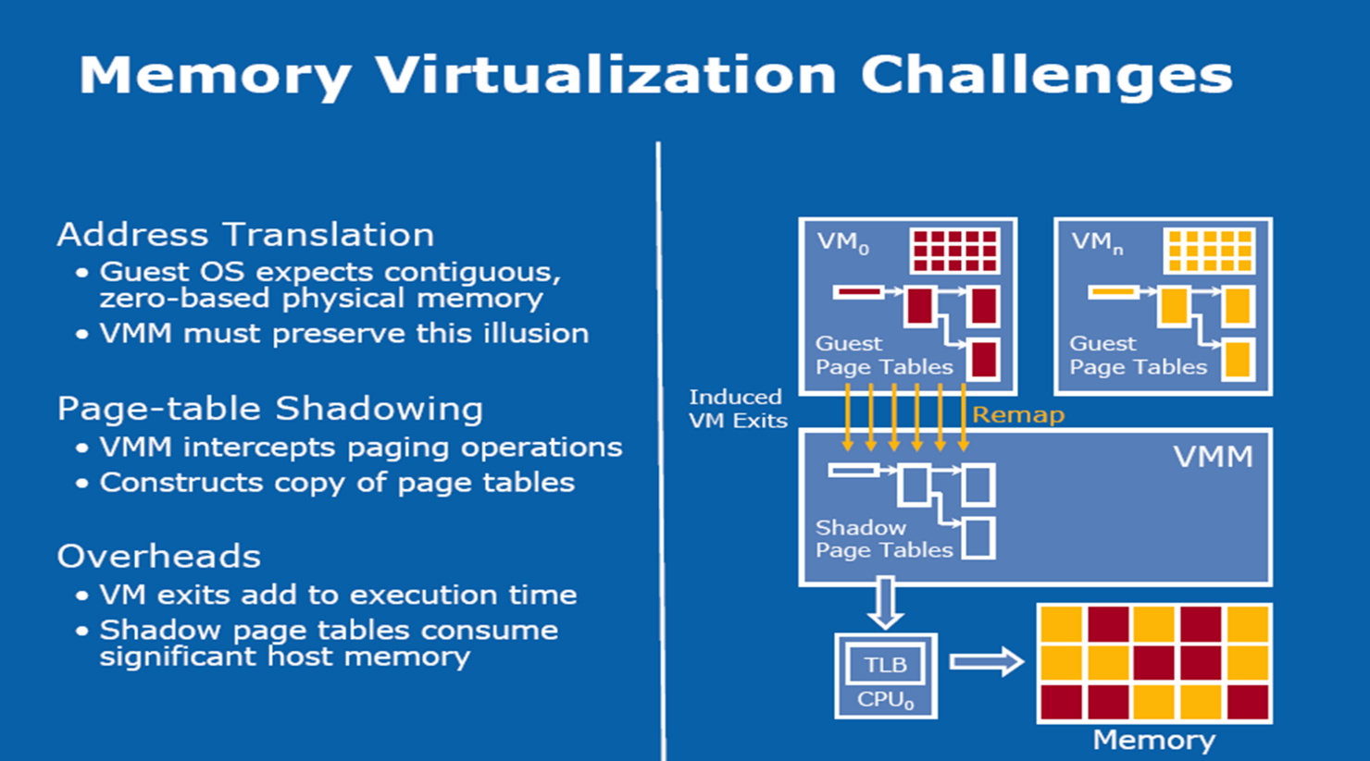

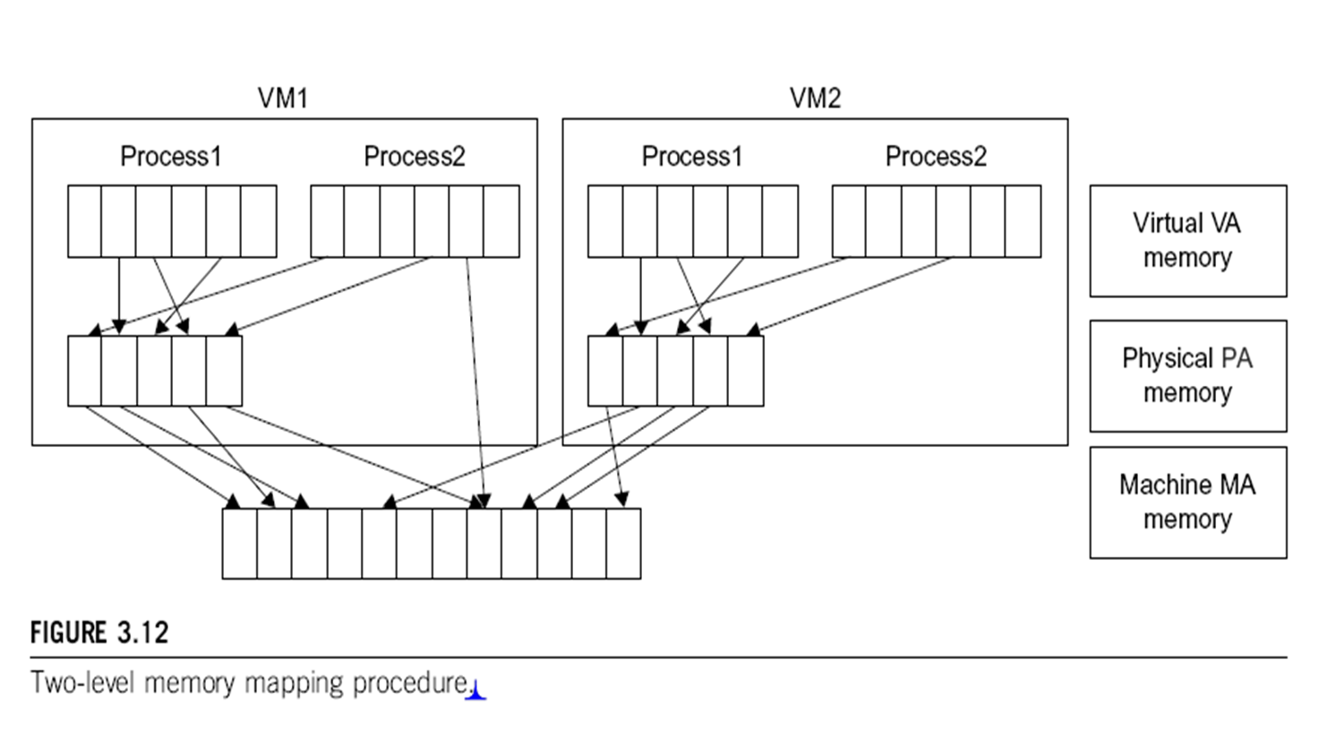

**Conclusions on CPU, Memory   
and I/O Virtualization:**

**CPU virtualization** demands hardware-assisted traps of   
 sensitive instructions by the VMM

**Memory virtualization** demands special hardware support   
 (shadow page tables by VMWare or extended page table by   
 Intel) to help translate virtual address into physical address   
 and machine memory in two stages.

**I/O virtualization** is the most difficult one to realize due to  
 the complexity if I/O service routines and the emulation   
 needed between the guest OS and host OS.

**Multi-Core Virtualization:   
VCPU vs. traditional CPU**

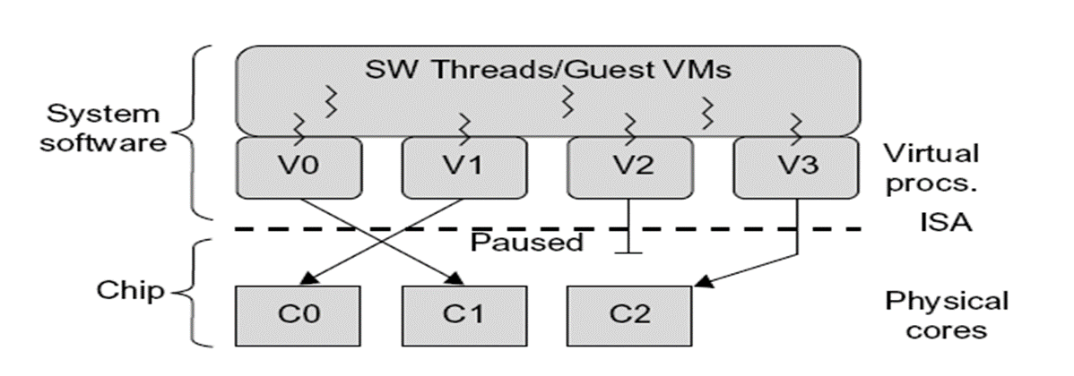

Four VCPUs are exposed the software, only three cores are actually present. VCPUs V0, V1, and V3 have been transparently migrated, while VCPU V2 has been transparently suspended. (Courtesy of Wells, et al., “Dynamic Heterogeneity and the Need for Multicore Virtualization”, ACM SIGOPS Operating Systems Review, ACM Press, 2009 [68])

**Lecture SIX**

**INTERPROCESS COMMUNICATION**

Exchange of data between two or more separate, independent processes/threads.

Operating systems provide facilities/resources for inter-process communications (IPC), such as message queues, semaphores, and shared memory.

Distributed computing systems make use of these facilities/resources to provide application programming interface (API) which allows IPC to be programmed at a higher level of abstraction. (e.g., send and receive)

Distributed computing requires information to be exchanged among independent processes.

**Interprocess Communications in Distributed Computing**



**Operations provided in an archetypal Interprocess Communications API**

**Receive** ([sender], message storage object)

**Connect** (sender address, receiver address), for connection-oriented communication.

**Send** ([receiver], message)

**Disconnect** (connection identifier), for connection-oriented communication.

**Interprocess Communication in basic HTTP**



Processing order: C1, S1, C2, S2, S3, C3, C4, S4

**Event Synchronization**

**Interprocess communication** may require that the two processes synchronize their operations: one side sends, then the other receives until all data has been sent and received.

Ideally, the **send operation starts** before the receive operation commences.

In practice, the **synchronization** requires system support.

**Synchronous vs. Asynchronous Communication**

The IPC operations may provide the **synchronization** necessary using **blocking**. A **blocking operation** issued by a process will block further processing of the process until the operation is fulfilled.

Alternatively, **IPC** operations may be **asynchronous** or **nonblocking**. An **asynchronous operation** issued by a process will not block further processing of the process. Instead, the process is **free to proceed** with its processing, and may optionally be notified by the system when the operation is fulfilled.

**Introduction**

The java API for interprocess communication in the internet provides both datagram and stream communication.

The two communication patterns that are most commonly used in distributed programs:

**Client-Server communication**

The request and reply messages provide the basis for remote method invocation (RMI) or remote procedure call (RPC).

**Group communication**

The same message is sent to several processes.

**This chapter is concerned with middleware**

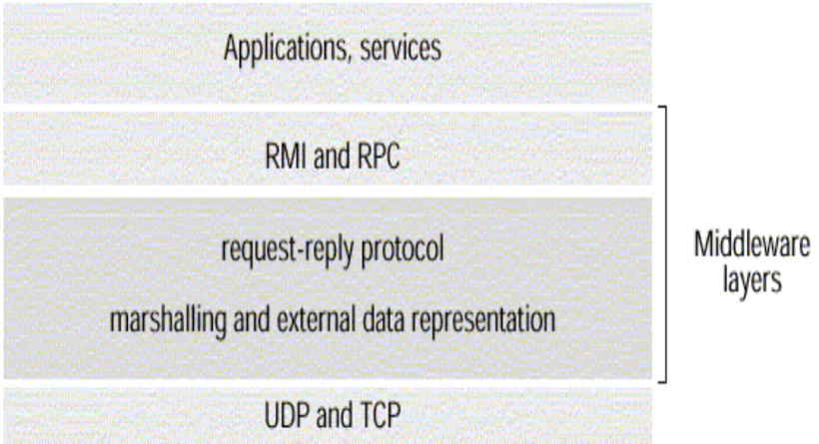

**Remote Method Invocation (RMI)**

It allows an object to invoke a method in an object in a remote process.

E.g. CORBA and Java RMI

**Remote Procedure Call (RPC)**

It allows a client to call a procedure in a remote server.

**The application program interface   
(API)** to **User Datagram Protocol (UDP)** provides a message **passing** abstraction.

Message passing is the simplest form of interprocess communication.

API enables a sending process to transmit a single message to a receiving process.

The independent packets containing theses messages are called datagrams.

In the Java and UNIX APIs, the sender specifies the destination using a socket.

**Q: What is the use of UDP in Network Applications?**

**Socket** is an indirect reference to a particular port used by the destination process at a destination computer.

The application program interface (API) to TCP provides the abstraction of a two-way stream between pairs of processes.

The information communicated consists of a stream of data items with no message boundaries.

**Request-reply protocols** are designed to support client-server communication in the form of either RMI or RPC.

**Group multicast protocols** are designed to support group communication.

**Group multicast** is a form of interprocess communication in which one process in a group of processes transmits the same message to all members of the group.

**The API for the Internet Protocols**

**The Characteristics of Interprocess Communication**

**Synchronous and asynchronous communication**

In the synchronous form, both send and receive are blocking operations.

In the asynchronous form, the use of the send operation is non-blocking and the receive operation can have blocking and non-blocking variants.

**Message destinations**

A local port is a message destination within a computer, specified as an integer.

A port has an exactly one receiver but can have many senders.

**Reliability**

A reliable communication is defined in terms of validity and integrity.

A point-to-point message service is described as reliable if messages are guaranteed to be delivered despite a reasonable number of packets being dropped or lost.

For integrity, messages must arrive uncorrupted and without duplication.

**Processes in the OS can send and receive messages via a socket**

**A socket is an interface between the application and the network (the lower levels of the protocol stack)**

The application creates a socket

The socket type dictates the style of communication

reliable vs. best effort

connection-oriented vs. connectionless

**Once a socket is setup the application can:**

pass data to the socket for network transmission

receive data from the socket (transmitted through the network, sent by some other host)

**Ordering**

Some applications require that messages be delivered in sender order.

**Most Popular Types of Sockets**

**TCP Socket**

Type: SOCK_STREAM

reliable delivery

in-order guaranteed

connection-oriented

bidirectional

**UDP Socket**

Type: SOCK_DGRAM

unreliable delivery

no order guarantees

no notion of “connection” – app indicates destination for each packet

can send or receive

**Socket Creation in C**

int s = socket(domain, type, protocol);

**s: socket descriptor, an integer (like a file-handle)**

**domain: integer, communication domain**

e.g., PF_INET (IPv4 protocol) – typically used

**type: communication type**

SOCK_STREAM: reliable, 2-way, connection-based service

SOCK_DGRAM: unreliable, connectionless,

other values: need root permission, rarely used, or obsolete

**protocol: specifies protocol (see file /etc/protocols for a list of options) - usually set to 0**

NOTE: socket call does not specify where data will be coming from, nor where it will be going to; it just creates the interface.

**Sockets**

Internet IPC mechanism of Unix and other operating systems (BSD Unix, Solaris, Linux, Windows NT, Macintosh OS)

Processes in the above OS can send and receive messages via a socket.

Sockets need to be bound to a port number and an internet address in order to send and receive messages.

Each socket has a transport protocol (TCP or UDP).

Messages sent to some internet address and port number can only be received by a process using a socket that is bound to this address and port number.

Processes cannot share ports (exception: TCP multicast).

Both forms of communication, UDP and TCP, use the socket abstraction, which provides and endpoint for communication between processes.

Interprocess communication consists of transmitting a message between a socket in one process and a socket in another process.

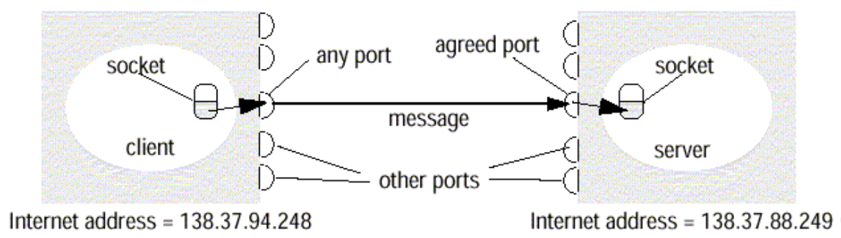

Sockets and ports

**UDP Datagram Communication**

**UDP datagram properties**

No guarantee of order preservation

Message loss and duplications are possible

**Necessary steps**

Creating a socket

Binding a socket to a port and local Internet address

A client binds to any free local port

A server binds to a server port

**Receive method**

It returns Internet address and port of sender, plus message.

**Issues related to datagram communications are:**

**Message size**

IP allows for messages of up to 216 bytes.

Most implementations restrict this to around 8 Kbytes.

Any application requiring messages larger than the maximum must fragment.

If arriving message is too big for array allocated to receive message content, truncation occurs.

**Blocking**

**Send: non-blocking**

upon arrival, message is placed in a queue for the socket that is bound to the destination port.

**Receive: blocking**

Pre-emption by timeout possible

If process wishes to continue while waiting for packet, use separate thread

**UDP datagrams suffer from following failures:**

Omission failure

Messages may be dropped occasionally,

Ordering

**Java API for UDP Datagrams**

The Java API provides datagram communication by two classes:

**Datagram Packet**

**It provides a constructor to make an array of bytes comprising:**

Message content

Length of message

Internet address

Local port number

**It provides another similar constructor for receiving a message.**

**Datagram Socket**

This class supports sockets for sending and receiving UDP datagram.

It provides a constructor with port number as argument.

No-argument constructor is used to choose a free local port.

**Datagram Socket methods are:**

send and receive

setSoTimeout

connect

**Example**

– The process creates a socket, sends a message to a server at port 6789 and waits to receive a reply.

import java.net. *;

import java.io. *;

public class UDPClient {

public static void main (String args []) {

// args give message contents and destination hostname

try {

DatagramSocket aSocket = new DatagramSocket (); // create socket

byte [] m = args [0]. getBytes ();

InetAddress aHost = InetAddress.getByName(args [1]); // DNS lookup

int serverPort = 6789;

DatagramPacket request =

new DatagramPacket (m, args [0]. length (), aHost, serverPort);

aSocket.send(request); //send nessage

byte [] buffer = new byte [1000];

DatagramPacket reply = new DatagramPacket (buffer, buffer.length);

aSocket.receive(reply); //wait for reply

System.out.println("Reply: " + new String (reply. getData ()));

aSocket.close();

} catch (SocketException e) {System.out.println("Socket: " + e.getMessage());

} catch (IOException e) {System.out.println("IO: " + e.getMessage());}

} finally {if (aSocket !=null) aSocket.close()}

}

}

UDP client sends a message to the server and gets a reply

**Example**

– The process creates a socket, bound to its server port 6789 and waits to receive a request message from a client.

import java.net. *;

import java.io. *;

public class UDPServer{

public static void main(String args[]){

DatagramSocket aSocket = null;

try {

aSocket = new DatagramSocket(6789);

byte [] buffer = new byte[1000];

While(true){

DatagramPacket request =new DatagramPacket(buffer, buffer.length);

aSocket.receive(request);

DatagramPacket reply = new DatagramPacket(request.getData();

request.getLength(),request.getAddress(), request.getPort();

aSocket.send(reply);

}

}catch (SocketException e){System.out.println("Socket: " + e.getMessage());

}catch (IOException e){System.out.println("IO: " + e.getMessage());}

}finally{if (aSocket !=null)aSocket.close()}

}

}

UDP server repeatedly receives a request and sends it back to the client

**TCP Stream Communication**

The API to the TCP protocol provides the abstraction of a stream of bytes to be written to or read from.

**Characteristics of the stream abstraction:**

Message sizes

Lost messages

Flow control

Message destinations

**Issues related to stream communication:**

Matching of data items

Blocking

Threads

**Use of TCP**

**Many services that run over TCP connections, with reserved port number are:**

HTTP (Hypertext Transfer Protocol)

FTP (File Transfer Protocol)

Telnet

SMTP (Simple Mail Transfer Protocol)

**Java API for TCP streams**

The Java interface to TCP streams is provided in the classes:

**ServerSocket**

It is used by a server to create a socket at server port to listen for connect requests from clients.

**Socket**

It is used by a pair of processes with a connection.

The client uses a constructor to create a socket and connect it to the remote host and port of a server.

It provides methods for accessing input and output streams associated with a socket.

**Example**

– The server process opens a server socket to its server port 6789 and listens for connect requests.

import java.net.*;

import java.io.*;

public class TCPServer {

public static void main (String args[]) {

try{

int serverPort = 7896;

ServerSocket listenSocket = new ServerSocket(serverPort);

while(true) {

Socket clientSocket = listenSocket.accept();

Connection c = new Connection(clientSocket);

}

} catch(IOException e) {System.out.println("Listen socket:"+e.getMessage());}

}

}

. TCP server makes a connection for each client and then echoes the client’s request

class Connection extends Thread {

DataInputStream in;

DataOutputStream out;

Socket clientSocket;

public Connection (Socket aClientSocket) {

try {

clientSocket = aClientSocket;

in = new DataInputStream( clientSocket.getInputStream());

out =new DataOutputStream( clientSocket.getOutputStream());

this.start();

} catch(IOException e){System.out.println("Connection:"+e.getMessage());}

}

public void run(){

try { // an echo server

String data = in.readUTF();

out.writeUTF(data);

} catch (EOFException e){System.out.println("EOF:"+e.getMessage());

} catch (IOException e) {System.out.println("readline:"+e.getMessage());}

} finally {try{clientSocket.close();}catch(IOException e){/*close failed*/}}

}

}

TCP server makes a connection for each client and then echoes the client’s request

**External Data Representation**

The information stored in running programs is represented as data structures, whereas the information in messages consists of sequences of bytes.

Irrespective of the form of communication used, the data structure must be converted to a sequence of bytes before transmission and rebuilt on arrival.

External Data Representation is an agreed standard for the representation of data structures and primitive values.

**Data representation problems are:**

Using agreed external representation, two conversions necessary

Using sender’s or receiver’s format and convert at the other end

**Marshalling**

Marshalling is the process of taking a collection of data items and assembling them into a form suitable for transmission in a message.

**Unmarshalling**

Unmarshalling is the process of disassembling a collection of data on arrival to produce an equivalent collection of data items at the destination.

**Three approaches to external data representation and marshalling are:**

CORBA

Java’s object serialization

XML

**Marshalling and unmarshalling activities** is usually performed automatically by middleware layer.

**Marshalling** is likely error-prone if carried out by hand.

**CORBA Common Data Representation (CDR)**

CORBA CDR is the external data representation defined with CORBA 2.0.

**It consists 15 primitive types:**

Short (16 bit)

Long (32 bit)

Unsigned short

Unsigned long

Float(32 bit)

Double(64 bit)

Char

Boolean(TRUE,FALSE)

Octet(8 bit)

Any(can represent any basic or constructed type)

Composite type are shown

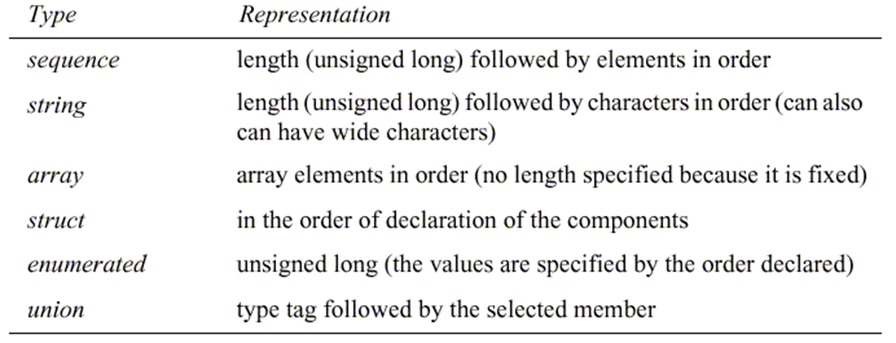

CORBA CDR for constructed types

**Constructed types:** The primitive values that comprise each constructed type are added to a sequence of bytes in a particular order.

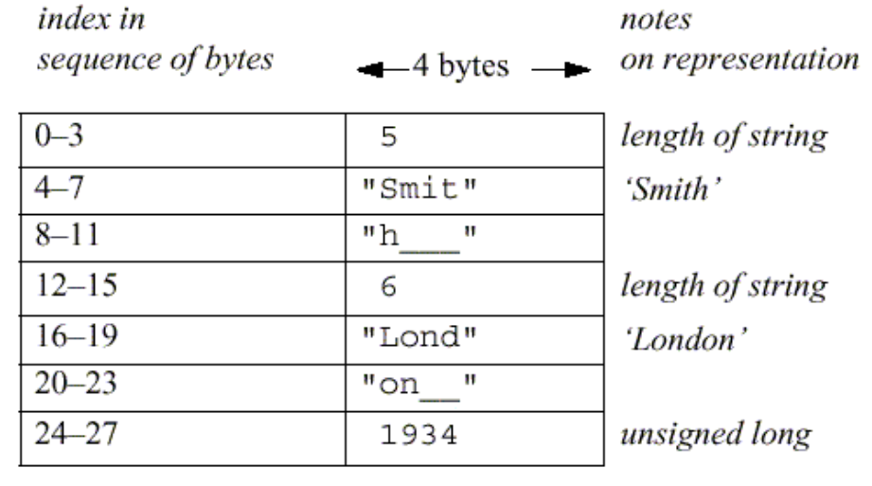**CORBA CDR message**

shows a message in CORBA CDR that contains the three fields of a struct whose respective types are string, string, and unsigned long. example: struct with value {‘Smith’, ‘London’, 1934}

**Java object serialization**

In Java RMI, both object and primitive data values may be passed as arguments and results of method invocation.

An object is an instance of a Java class.

**Example, the Java class equivalent to the Person struct**

Public class Person implements Serializable {

Private String name;

Private String place;

Private int year;

Public Person(String aName ,String aPlace, int aYear) {

name = aName;

place = aPlace;

year = aYear;

}

//followed by methods for accessing the instance variables

}

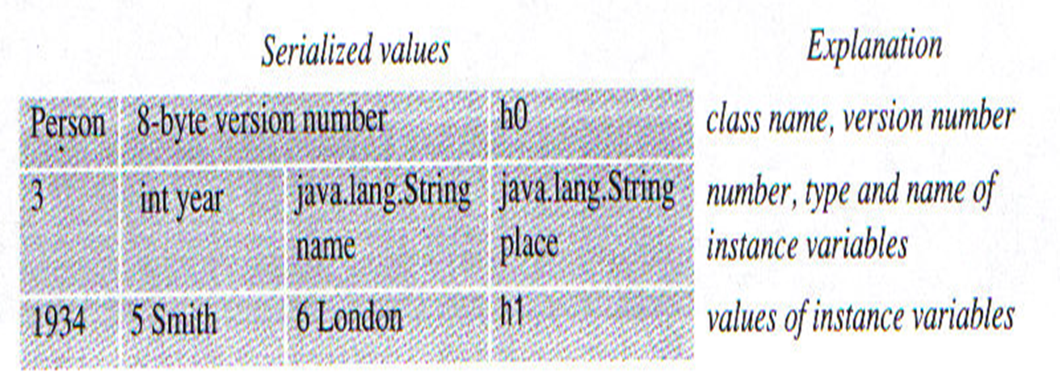

. Indication of Java serialization form

**Remote Object References**

Remote object references are needed when a client invokes an object that is located on a remote server.

A remote object reference is passed in the invocation message to specify which object is to be invoked.

Remote object references must be unique over space and time.

In general, may be many processes hosting remote objects, so remote object referencing must be unique among all of the processes in the various computers in a distributed system.

generic format for remote object references

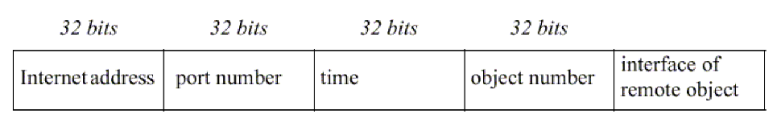

Representation of a remote object references

internet address/port number: process which created object

time: creation time

object number: local counter, incremented each time an object is created in the creating process

interface: how to access the remote object (if object reference is passed from one client to another)

**Client-Server Communication**

The client-server communication is designed to support the roles and message exchanges in typical client-server interactions.

In the normal case, request-reply communication is synchronous because the client process blocks until the reply arrives from the server.

Asynchronous request-reply communication is an alternative that is useful where clients can afford to retrieve replies later.

Often built over UDP datagrams

Client-server protocol consists of request/response pairs, hence no acknowledgements at transport layer are necessary

Avoidance of connection establishment overhead

No need for flow control due to small amounts of data are transferred

The request-reply protocol was based on a trio of communication primitives: doOperation, getRequest, and sendReply

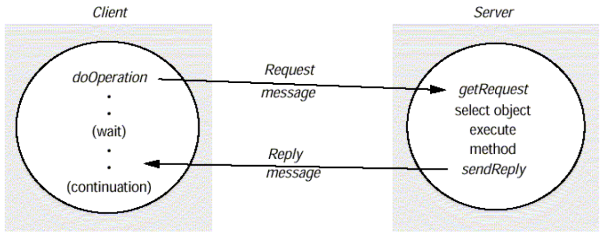

Request-reply communication

The designed request-reply protocol matches requests to replies.

If UDP datagrams are used, the delivery guarantees must be provided by the request-reply protocol, which may use the server reply message as an acknowledgement of the client request message.

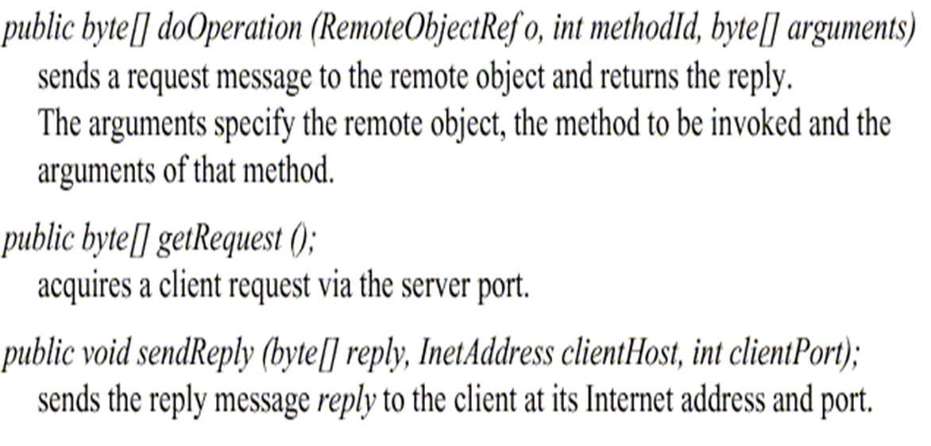

outlines the three communication primitives

The information to be transmitted in a request message or a reply message

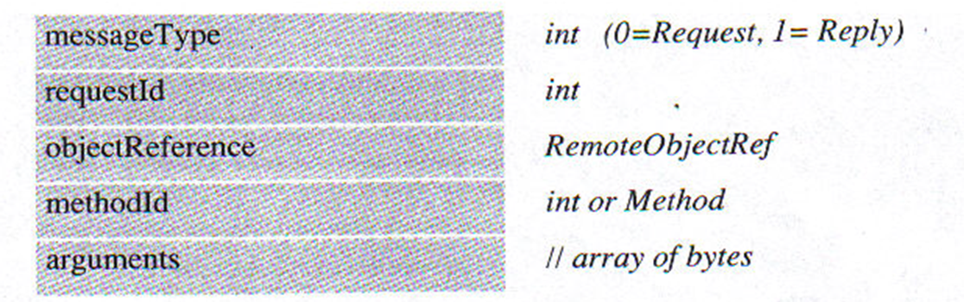

Request-reply message structure

**In a protocol message**

The first field indicates whether the message is a request or a reply message.

The second field request id contains a message identifier.

The third field is a remote object reference .

The forth field is an identifier for the method to be invoked.

**Message identifier**

A message identifier consists of two parts:

A requestId, which is taken from an increasing sequence of integers by the sending process

An identifier for the sender process, for example its port and Internet address.

**Failure model of the request-reply protocol**

If the three primitive doOperation, getRequest, and sendReply are implemented over UDP datagram, they have the same communication failures.

Omission failure

Messages are not guaranteed to be delivered in sender order.

**RPC exchange protocols**

Three protocols are used for implementing various types of RPC.

The request (R) protocol.

The request-reply (RR) protocol.

The request-reply-acknowledge (RRA) protocol.

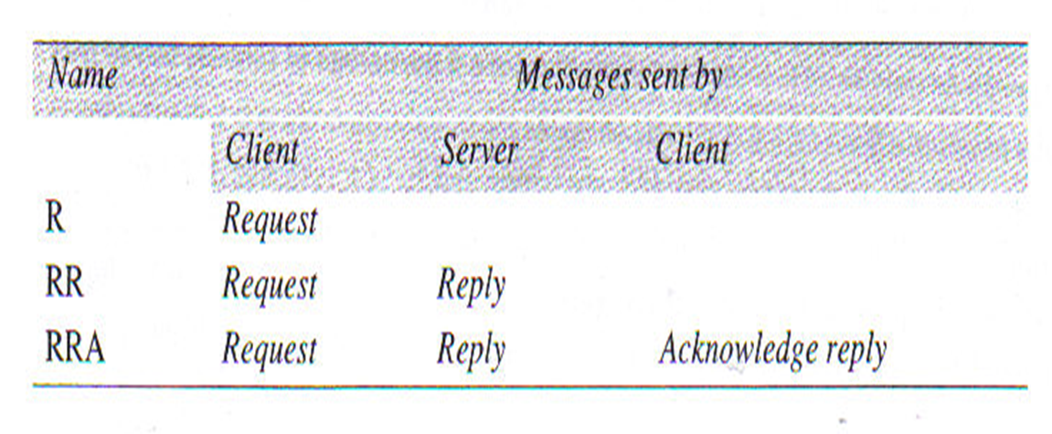

In the **R protocol**, a single request message is sent by the client to the server.

The **R protocol** may be used when there is no value to be returned from the remote method.

The **RR protocol** is useful for most client-server exchanges because it is based on request-reply protocol.

**RRA protocol** is based on the exchange of three messages: request-reply-acknowledge reply.

**HTTP: an example of a request-reply protocol**

HTTP is a request-reply protocol for the exchange of network resources between web clients and web servers.

**HTTP protocol steps are:**

Connection establishment between client and server at the default server port or at a port specified in the URL

client sends a request

server sends a reply

connection closure

**HTTP 1.1 uses persistent connections.**

Persistent connections are connections that remains open over a series of request-reply exchanges between client and server.

Resources can have Multipurpose Internet Mail Extensions **(MIME)-like** structures in arguments and results.

**A Mime type** specifies a type and a subtype, for example:

text/plain

text/html

image/gif

image/jpeg

**HTTP methods**

**GET**

Requests the resource, identified by URL as argument.

If the URL refers to data, then the web server replies by returning the data

If the URL refers to a program, then the web server runs the program and returns the output to the client.

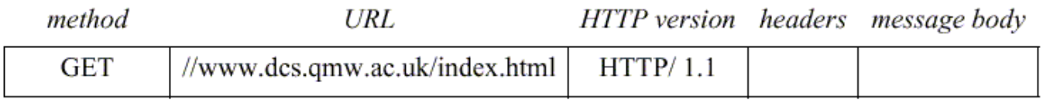

**POST**

Specifies the URL of a resource (for instance, a server program) that can deal with the data supplied with the request.

**This method is designed to deal with:**

Providing a block of data to a data-handling process

Posting a message to a bulletin board, mailing list or news group.

Extending a dataset with an append operation

**PUT**

Supplied data to be stored in the given URL as its identifier.

**DELETE**

The server deletes an identified resource by the given URL on the server.

**OPTIONS**

A server supplies the client with a list of methods.

It allows to be applied to the given URL

**TRACE**

The server sends back the request message

**A reply message specifies**

The protocol version

A status code

Reason

Some headers

An optional message body

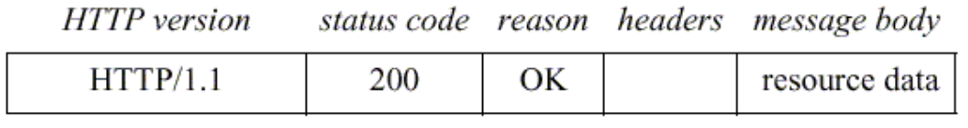

**Group Communication**

The pairwise exchange of messages is not the best model for communication from one process to a group of other processes.

A **multicast operation** is more appropriate.

**Multicast operation** is an operation that sends a single message from one process to each of the members of a group of processes.

The simplest way **of multicasting**, provides no guarantees about message delivery or ordering.

**Multicasting has the following characteristics:**

Fault tolerance based on replicated services

A replicated service consists of a group of servers.

Client requests are multicast to all the members of the group, each of which performs an identical operation.

**Finding the discovery servers in spontaneous networking**

Multicast messages can be used by servers and clients to locate available discovery services in order to register their interfaces or to look up the interfaces of other services in the distributed system.

**Better performance through replicated data**

Data are replicated to increase the performance of a service.

**Propagation of event notifications**

Multicast to a group may be used to notify processes when something happens.

**IP multicast**

IP multicast is built on top of the Internet protocol, IP.

IP multicast allows the sender to transmit a single IP packet to a multicast group.

A multicast group is specified by class D IP address for which first 4 bits are 1110 in IPv4.

The membership of a multicast group is dynamic.

A computer belongs to a multicast group if one or more processes have sockets that belong to the multicast group.

**The following details are specific to IPv4:**

**Multicast IP routers**

IP packets can be multicast both on local network and on the wider Internet.

Local multicast uses local network such as Ethernet.

To limit the distance of propagation of a multicast datagram, the sender can specify the number of routers it is allowed to pass- called the time to live, or TTL for short.

**Multicast address allocation**

Multicast addressing may be permanent or temporary.

Permanent groups exist even when there are no members.

Multicast addressing by temporary groups must be created before use and cease to exit when all members have left.

The session directory (sd) program can be used to start or join a multicast session.

session directory provides a tool with an interactive interface that allows users to browse advertised multicast sessions and to advertise their own session, specifying the time and duration.

**Java API to IP multicast**

The Java API provides a datagram interface to IP multicast through the class **MulticastSocket,** which is a subset of **DatagramSocket** with the additional capability of being able to join multicast groups.

The class **MulticastSocke**t provides two alternative constructors , allowing socket to be creative to use either a specified local port, or any free local port.

import java.net.*;

import java.io.*;

public class MulticastPeer{

public static void main(String args[]){

// args give message contents and destination multicast group (e.g. "228.5.6.7")

MulticastSocket s =null;

try {

InetAddress group = InetAddress.getByName(args[1]);

s = new MulticastSocket(6789);

s.joinGroup(group);

byte [] m = args[0].getBytes();

DatagramPacket messageOut = new DatagramPacket(m, m.length, group, 6789);

s.send(messageOut);

byte[] buffer = new byte[1000];

for(int i=0; i< 3;i++) { // get messages from others in group

DatagramPacket messageIn = new DatagramPacket(buffer, buffer.length);

s.receive(messageIn);

System.out.println("Received:" + new String(messageIn.getData()));

}

s.leaveGroup(group);

}catch (SocketException e){System.out.println("Socket: " + e.getMessage());

}catch (IOException e){System.out.println("IO: " + e.getMessage());

}finally {if(s != null) s.close();}

}

}

. Multicast peer joins a group and sends and receives datagrams

A process can join a multicast group with a given multicast address by invoking **the joinGroup** method of its multicast socket.

A process can leave a specified group by invoking the **leaveGroup** method of its multicast socket.

The Java API allows the TTL to be set for a multicast socket by means of the **setTimeToLive** method. The default is 1, allowing the multicast to propagate only on the local network

**Lecture Seven**

**Distributed Algorithms**

**Routing Algorithms in Computer Networks - Distance Vector, Link State**Data is converted into packets in computer networks before being transferred from source to destination.

The network layer chooses the best path for data packet transmission.

The network layers provide a routing protocol, which is a routing algorithm that determines the best and shortest path for transmitting data from source to destination.

Routing algorithms are an essential component of computer networks.

Without them, data cannot flow between different parts of the network.

This article will look at the various types of routing algorithms and how they work.

**What is Routing Algorithm?**A routing algorithm is a routing protocol determined by the network layer for transmitting data packets from source to destination.

This algorithm determines the best or least-cost path for data transmission from sender/source to receiver/destination.

The network layer performs operations that effectively and efficiently regulate internet traffic. In computer networks, this is known as a routing algorithm. It is used to determine the best path or route mathematically.

**What is an Algorithm?**an algorithm is a set of well-defined instructions to solve a particular problem. It takes a set of input(s) and produces the desired output;

**Qualities of a good algorithm:**

Input and output should be defined precisely.

Each step in the algorithm should be clear and unambiguous.

Algorithms should be most effective among many different ways to solve a problem.

An algorithm shouldn't include computer code. Instead, the algorithm should be written in such a way that it can be used in different programming languages.

**From the perspective of Distributed Systems**

**A distributed algorithm** is an algorithm designed to run on computer hardware constructed from interconnected processors.

**Distributed algorithms** are algorithms designed to run on multiple processors, without tight centralized control. In general, they are harder to design and harder to understand than single-processor sequential algorithms.

**Distributed Algorithms**

Distributed algorithms are a sub-type of parallel algorithm, typically executed concurrently, with separate parts of the algorithm being run simultaneously on independent processors, and having limited information about what the other parts of the algorithm are doing.

One of the major challenges in developing and implementing distributed algorithms is successfully coordinating the behavior of the independent parts of the algorithm in the face of processor failures and unreliable communications links.

The choice of an appropriate distributed algorithm to solve a given problem depends on both the characteristics of the problem, and characteristics of the system the algorithm will run on such as the type and probability of processor or link failures, the kind of inter-process communication that can be performed, and the level of timing synchronization between separate processes.[

Distributed Algorithm are algorithms designed to run large but limited set of processors that run similar programs.

It runs on a distributed system that does not assume the previous existence of a central coordinator.

A distributed system is a group of processors that do not share memory or a clock.

Each process has its own memory and the processors use communication networks to communicate.

Distributed algorithms are used in various practical systems, ranging from large computer networks to multiprocessor shared-memory systems.

The development of distributed algorithms are different in nature from the development of centralized algorithms. Distributed system differs from centralized system

**Standard problems**

**Atomic commit** An atomic commit is an operation where a set of distinct changes is applied as a single operation.

If the atomic commit succeeds, it means that all the changes have been applied. If there is a failure before the atomic commit can be completed, the "commit" is aborted and no changes will be applied.

Algorithms for solving the atomic commit problem include the **two-phase commit protocol** and the **three-phase commit protocol**. **Consensus** Consensus algorithms try to solve the problem of a number of processes agreeing on a common decision.

**More precisely, a Consensus protocol must satisfy the four formal properties below.**

**Termination**: every correct process decides some value.

**Validity**: if all processes propose the same value v , then every correct process decides v .

**Integrity**: every correct process decides at most one value, and if it decides some value v , then v must have been proposed by some process.

**Agreement**: if a correct process decides v , then every correct process decides v .

Common algorithms for solving consensus are the Paxos algorithm and the Raft algorithm.

**Distributed Systems Compared to Parallel Systems**

**The Three Walls of High-Performance Computing:**

**Memory-wall challenge:**

Memory already limits single-processor performance. How can we design a memory system that provides a bandwidth of several terabytes/s for data-intensive high-performance applications?

**Power-wall challenge:**

When there are millions of processing nodes, each drawing a few watts of power, we are faced with the energy bill and cooling challenges of MWs of power dissipation, even ignoring the power needs of the interconnection network and peripheral devices

**Reliability-wall challenge:**

Ensuring continuous and correct functioning of a system with many thousands or even millions of processing nodes is non-trivial, given that a few of the nodes are bound to malfunction at an given time

**Understand orders of magnitude in computer performance**

**GigaFLOPS**

A 1 gigaFLOPS (GFLOPS) computer system is capable of performing one billion (109) floating-point operations per second. To match what a 1 GFLOPS computer system can do in just one second, you'd have to perform one calculation every second for 31.69 years.

**TeraFLOPS**

A 1 teraFLOPS (TFLOPS) computer system is capable of performing one trillion (1012) floating-point operations per second. The rate 1 TFLOPS is equivalent to 1,000 GFLOPS. To match what a 1 TFLOPS computer system can do in just one second, you'd have to perform one calculation every second for 31,688.77 years.

**PetaFLOPS**

A 1 petaFLOPS (PFLOPS) computer system is capable of performing one quadrillion (1015) floating-point operations per second. The rate 1 PFLOPS is equivalent to 1,000 TFLOPS. To match what a 1 PFLOPS computer system can do in just one second, you'd have to perform one calculation every second for 31,688,765 years.

**ExaFLOPS**

A 1 exaFLOPS (EFLOPS) computer system is capable of performing one quintillion (1018) floating-point operations per second. The rate 1 EFLOPS is equivalent to 1,000 PFLOPS. To match what a 1 EFLOPS computer system can do in just one second, you'd have to perform one calculation every second for 31,688,765,000 years.

**Distributed Algorithm: Distributed System vs Parallel System**

Distributed system refers to the all computer applications where several computers or processors are interconnected in some way.

It incorporates multiprocessor computers in which each processor has its own control unit, wide-area computer communication networks, local-area networks and systems of cooperating processes.

Following are some points of comparison between Distributed System and Parallel System:

**Process Synchronization**

Set of techniques that are used to coordinate execution amongst processes.

**For example**, a process may wish to run only to a certain point, at which it will stop and wait for another process to finish certain actions.

A common resource (such as a device or a location in memory) may require exclusive access and processes have to coordinate amongst themselves to ensure that access is fair and exclusive.

In centralized systems, it was common enforce exclusive access to shared code.

Mutual exclusion was accomplished through mechanisms such as test and set locks in hardware and semaphores(variable or adt for controlling access, by multiple processes, to a common resources in a multi user environment) messages, and condition variables in software.

**Distributed Algorithm: Distributed System vs Parallel System**

Distributed system refers to the all computer applications where several computers or processors are interconnected in some way.

It incorporates multiprocessor computers in which each processor has its own control unit, wide-area computer communication networks, local-area networks and systems of cooperating processes.

Following are some points of comparison between Distributed System and Parallel System

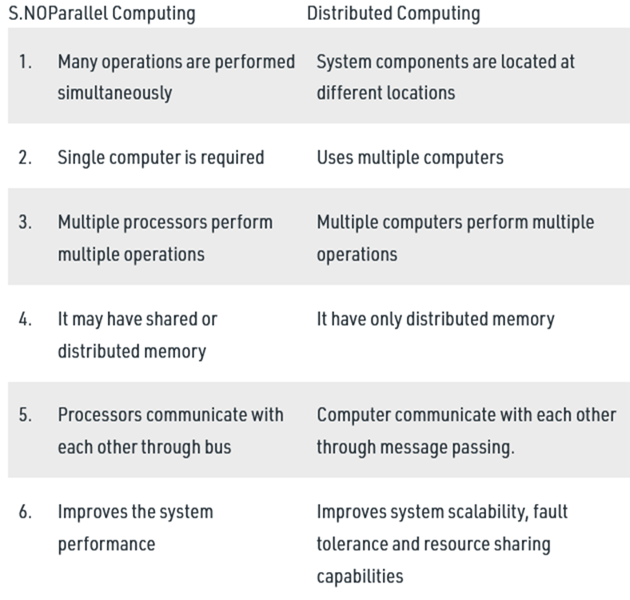

**Why synchronize clocks in Distributed Systems**

**You want to catch the 10 bodaboda at the Voi Town at 6.05 pm, but your watch is off by 5 minutes**

What if your watch is Faster by 5 minutes?

What if your watch is Late by 5 minutes?

**Synchronizing clocks helps us**

**Time-stamping events** (provide ‘Fairness’)

**Ordering events** (provide ‘Correctness’)

**Time Sources**

**De Facto Primary Standard – International Atomic Time (TAI)**

Keeping of TAI started in 1955

1 atomic second = 9,192,631,770 orbital transitions of Cs133 (Caesium)

86400 atomic seconds = 1 solar day – 3 ms

**Coordinated Universal Time (UTC) – International Standard**

Keeping of UTC started 1961

Derived from TAI by adding leap seconds to keep it close to solar time

UTC source signals are synchronized

UTC time is re-transmitted by GPS satellites

**Local clocks are based on oscillators**

**Terminology**

**Distributed System (DS)** consists of N **processes** p1, p2, .. pN

**Process pi, i є {1,…N}**

**State:** values of local variables including **time**

**Ci(t):** the reading of the **local clock** at process i when the real time is t

**Actions:** send message [send(m)], receive message [recv(m)], compute [comp]

**Occurrence of an action is called an event**

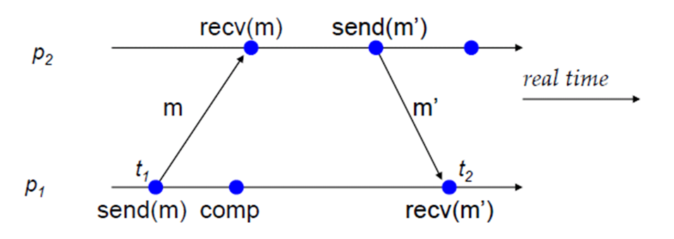

Events within process pi can be assigned **timestamp** and thus ordered

Events across different processes in DS need to be ordered, but

**Clocks in DS across processes are not synchronized**

Process clocks can be different

**Need algorithms for either**

time synchronization or

telling which event happened before which

**Distributed Mutual Exclusion**

We assume that there is group agreement on how a critical section (or exclusive resource) is identified (e.g. name, number) and that this identifier is passed as a parameter with any requests.

Create an algorithm to allow a process to obtain exclusive access to a resource.

**Mutual Exclusion in Distributed System:**

Mutual Exclusion ensures that no other process will use shared resources at same time..

One process is elected as coordinator.

Whenever process wants to enter a critical region , it sends request msg to coordinator asking for permission.

If no other process is currently in that critical region, the coordinator sends back a reply granting permission.

When reply arrives, the requesting process enters the critical region.

If the coordinator knows that a different process is already in critical regions, so it cannot be granted permission.

**Centralized Algorithm**

In centralized algorithm one process is elected as the coordinator which may be the mach

ine with the highest network address.

**Central Server algorithm**

Mimic single processor system

One process elected as coordinator

Request resource, Wait for response, Receive grant, access resource, Release resource

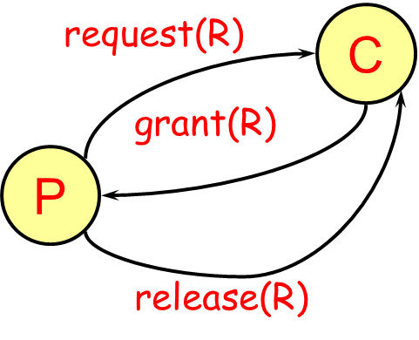

When a process wants to enter a critical section, it sends **a request** message (identifying the critical section, if there are more than one) to the coordinator.

If nobody is currently in the section, the coordinator sends back a **grant** message and marks that process as using the critical section.

If, however, another process has previously claimed the critical section, the server simply does not reply, so the requesting process is blocked.

When a process is done with its critical section, it sends a **release** message to the coordinator.

The coordinator then can send a grant message to the next process in its queue of processes requesting a critical section (if any).

**Benefits**

Fair

All requests processed in order

Easy to implement, understand, verify

**Problems**

Process cannot distinguish being blocked from a dead coordinator

Centralized server can be a bottleneck

**Ricart & Agrawala algorithm**

Distributed algorithm using reliable multicast and logical clocks

**Process wants to enter critical section:**

Compose message containing:

Identifier (machine ID, process ID)

Name of resource

Timestamp (totally-ordered Lamport)

Send request to all processes in group

Wait until everyone gives permission

Enter critical section / use resource

**When process receives request:**

If receiver not interested:

Send OK to sender

If receiver is in critical section

Do not reply; add request to queue

If receiver just sent a request as well:

Compare timestamps: received & sent messages

Earliest wins

If receiver is loser, send OK

If receiver is winner, do not reply, queue

**When done with critical section**

Send OK to all queued requests

**a single point of failure has now been replaced with n points of failure**. A poor algorithm has been replaced with one that is essentially n times worse.

**A lot of messaging traffic**

**Demonstrates that a fully distributed algorithm is possible**

**Lamport’s Mutual Exclusion**

**Each process maintains request queue**

Contains mutual exclusion requests

**Requesting critical section:**

Process Pi sends **request(i, Ti)** to all nodes

Places request on its own queue

When a process Pj receives a request, it returns a timestamped **ack**

**Entering critical section (accessing resource):**

Pi received a message **(ack or release)** from every other process with a timestamp larger than Ti

Pi’s request has the earliest timestamp in its queue

**Difference from Ricart-Agrawala:**

Everyone responds … always - no hold-back

Process decides to go based on whether its request is the earliest in its queue

**Releasing critical section:**

Remove request from its own queue

Send a timestamped release message

When a process receives a release message

Removes request for that process from its queue

This may cause its own entry have the earliest timestamp in the queue, enabling it to access the critical section

**Token Ring Algorithm**

assumes a group of processes with no inherent ordering of processes, but that some ordering can be

imposed on the group.

For example, we can identify each process by its

machine address and process ID to obtain an ordering.

Using this imposed ordering, a logical ring is constructed in software.

Each process is assigned a position in the ring and each process must know who is next to it in the ring

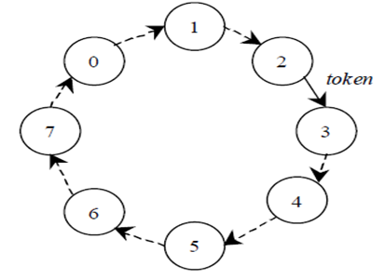

The ring is initialized by giving **a token** to process 0. The token circulates around the ring (process n passes it to (n+1)mod ringsize.

When a process acquires the token, it checks to see if it is attempting to enter the critical section. If so, it enters and does its work. On exit, it passes the token to its neighbor.

If a process isn't interested in entering a critical section, it simply passes the token along.

**Traditional Network Design Methodology**

Only one process has the token at a time and it must have the token to work on a critical section, so mutual exclusion is guaranteed. Order is also well-defined, so starvation cannot occur.

The biggest drawback of this algorithm is that if a token is lost, it will have to be generated. Determining that a token is lost can be difficult

**Election Algorithms**

**Example 1:** Your Bank maintains multiple servers, but for each customer, one of the servers is responsible, i.e., is the leader

**Example 2:** In the sequencer-based algorithm for total ordering of multicasts,

What happens if the “special” sequencer process fails?

**Example 3:** Coordinator-based distributed mutual exclusion: need to elect (and keep) one coordinator

**In a group of processes**, elect a Leader to undertake special tasks. Makes the algorithm design easy.

**But leader may fail (crash)**

Some process detects this

Then what?

**Assumptions and Requirements**

Any process can call for an election.

A process can call for at most one election at a time.

Multiple processes can call an election simultaneously.

The result of an election should not depend on which process calls for it.

**Each process has**

Variable called elected

An attribute value called attr, e.g., id, MAC address, CPU

The non-faulty process with the best (highest) election attribute value (e.g., highest id or address, or fastest cpu, etc.) is elected.

Requirement: A run (execution) of the election algorithm must always guarantee at the end.

We often need one process to act as a coordinator. It may not matter which process does this, but there should be group agreement on only one.

An assumption in election algorithms is that all processes are exactly the same with no distinguishing characteristics.

Each process can obtain a unique identifier (for example, a machine address and process ID) and each process knows of every other process but does not know which is up and which is down.

**What have we Learnt**

Coordination requires a leader process, e.g., sequencer for total ordering in multicasts, bank database example, coordinator-based mutual exclusion.

Leader process might fail

Need to (re-) elect leader process

Two Algorithms:

Bully algorithm

Ring Algorithm

**Election by the Bully Algorithm**

**Assumptions:**

**Synchronous system**

All messages arrive within Ttrans units of time.

A reply is dispatched within Tprocess units of time after the receipt of a message.

if no response is received in 2Ttrans + Tprocess, the node is assumed to be faulty (crashed).

**attr=id**

**Each process** knows all the other processes in the system (and thus their id’s)

**Bully algorithm**

Selects the process with the largest identifier as the coordinator.

**It works as follows:**

**When a process p detects that the coordinator is not responding to requests, it initiates an election**:

a. p sends an election message to all processes with higher numbers.

b. If nobody responds, then p wins and takes over.

c. If one of the processes answers, then p's job is done.

**If a process receives an election message from a lower-numbered process at any time, it:**

a. sends an OK message back.

b. holds an election (unless its already holding one).

**A process announces its victory by sending all processes a message telling them that it is the new coordinator.**

**If a process that has been down recovers, it holds an election**

**Performance of Bully Algorithm**

**Best case scenario:** The process with the second highest id notices the failure of the coordinator and elects itself.

N-2 coordinator messages are sent.

Turnaround time is one message transmission time.

**Worst case scenario:** When the process with the least id detects the failure.

N-1 processes altogether begin elections, each sending messages to processes with higher ids.

There will be message overhead.

Turnaround time is approximately 5 message transmission times if there are no failures during the run: election, answer, election, answer, coordinator

**Ring Algorithm**

Uses the same ring arrangement as in the token ring mutual exclusion algorithm, but does not employ a token.

Processes are physically or logically ordered so that each knows its successor.

If any process detects failure, it constructs an election message with its process I.D. (e.g. network address and local process I.D.) and sends it to its successor.

If the successor is down, it skips over it and sends the message to the next party. This process is repeated until a running process is located.

At each step, the process adds its own process I.D. to the list in the message.

Eventually, the message comes back to the process that started it:

1. The process sees its ID in the list.

2. It changes the message type to coordinator.

3. The list is circulated again, with each process selecting the highest numbered ID in the list to act as coordinator.

4. When the coordinator message has circulated fully, it is deleted.

Multiple messages may circulate if multiple processes detected failure. This creates a bit of overhead but produces the same results.